**Limited VRAM Memory Buffers & PCI Express Bandwidth Test PCIe 4.0 vs. PCIe 3.0 Gaming Performance**

Is the Radeon RX 6500 XT destined for failure?

AMD will release the Radeon RX6500 XT, their first RDNA2-based gaming product. The new GPU will be available at a MSRP of $200, although we expect it to go much higher than that after an initial limited run. The 6500 XT will likely end up retail priced at $300-$400, although that is a guess.

The 6500XT has a PCI Express 4.0x4 bandwidth limit. Although AMD has not yet made this public and we are bound by an NDA agreement, it was confirmed by Asrock so it's not a secret. What does this mean for the Radeon X6500 XT This is a subject that has divided opinions. Some people believe that this will cause card to crash, while others refer to PCI Express bandwidth testing using flagship graphics cards, which suggests that the 6500XT will work fine even in a PCI Express 3.0 environment.

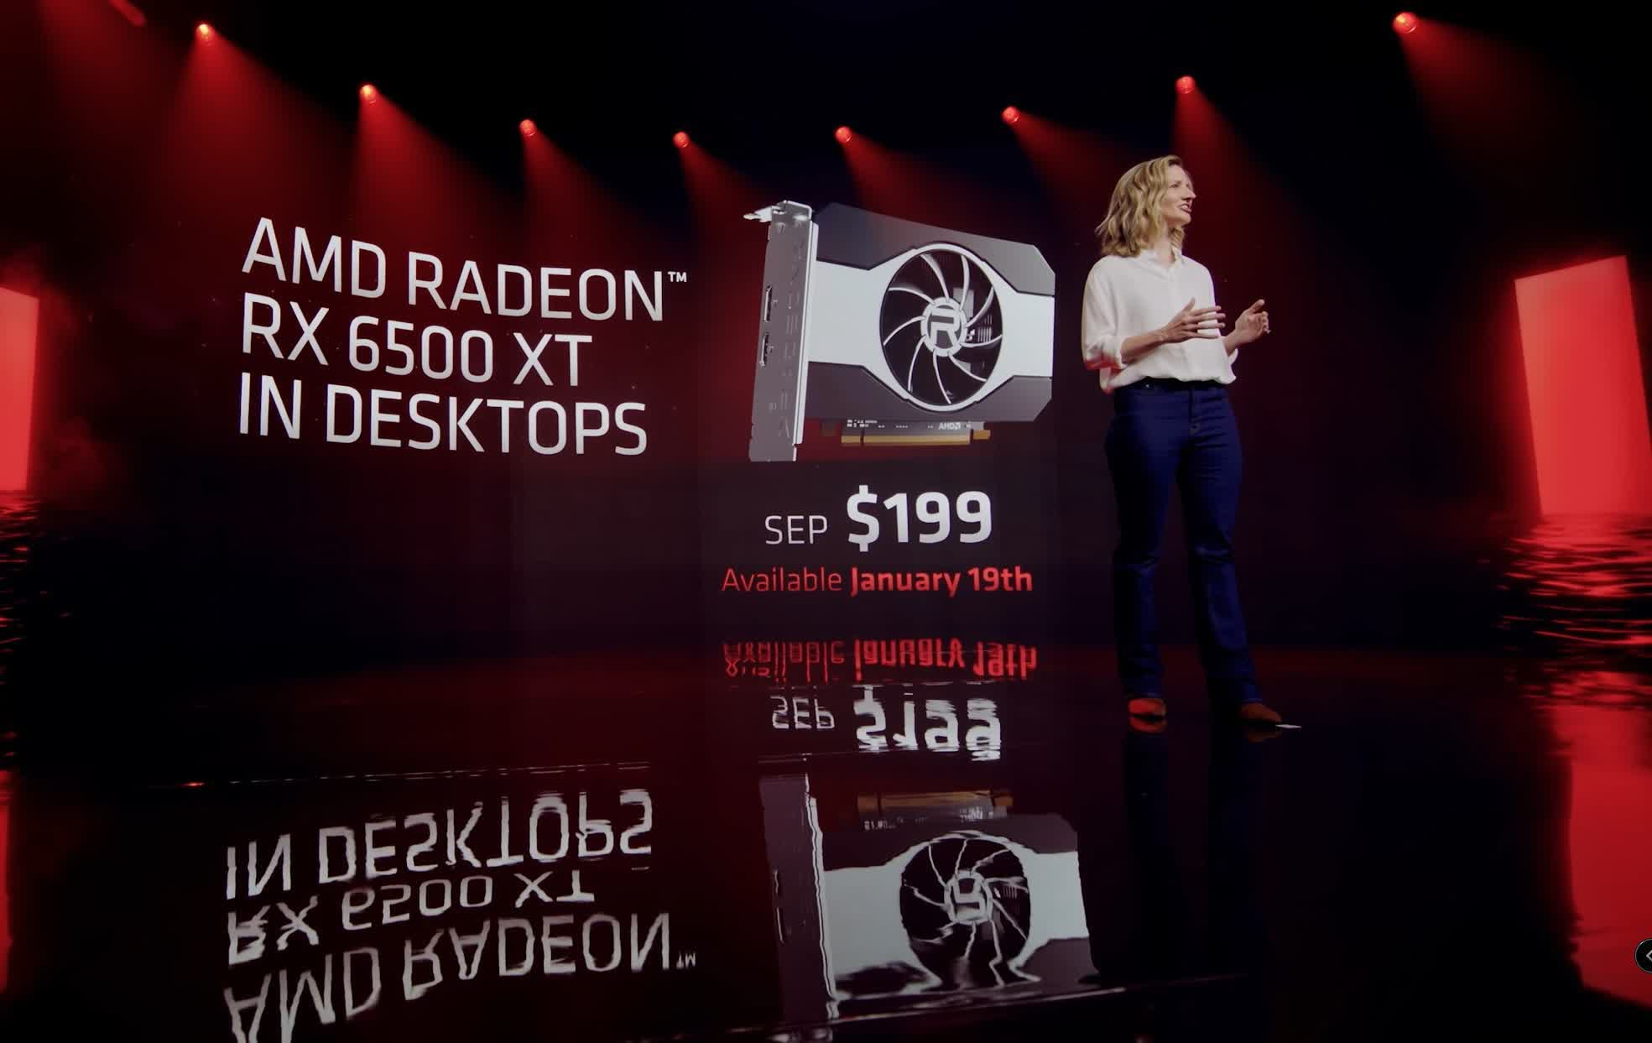

The 6500 XT has an 8 GB/s communication link with the CPU and system memory thanks to PCIe 4.0, which provides around 2 GB/s bandwidth per lane. However, if you put it in a PCIe 3.0 system, that figure is cut in half, and here is where you can run into issues.

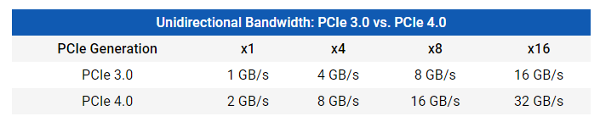

When constrained to 4 GB/s of PCIe bandwidth, the average frame rate performance of an RTX 3080 drops by only 10% at 1080p, according to TechPowerUp. Many people have thought that the 6500 XT will suffice, despite the fact that it is a substantially more powerful GPU. The issue with that assumption is that you're overlooking the fact that the RTX 3080 has a 10GB VRAM buffer, whilst the 6500 XT has just a 4GB VRAM buffer. The smaller the memory buffer, the more likely you are to use system memory, and here is where PCIe bandwidth limitations might cause problems.

The RTX 3080 was tested with ultra-quality settings, whereas the 6500 XT can be used to more dialed-down presets like'medium'. AMD claims that the PCIe 3.0 bandwidth will not be an issue with the 6500XT. Gamers should ensure that they don't exceed the memory buffer to achieve optimal performance. However, modern games require a 4GB graphics card.

We'll talk more about it at the end of this review. But for now, let's just explain what we are doing. We decided to not wait for 6500 XT reviews, even though they are just days away. Our original plan was to test PCIe performance using a similar product for internal reference. However, the results proved so compelling that we decided to create a complete feature.

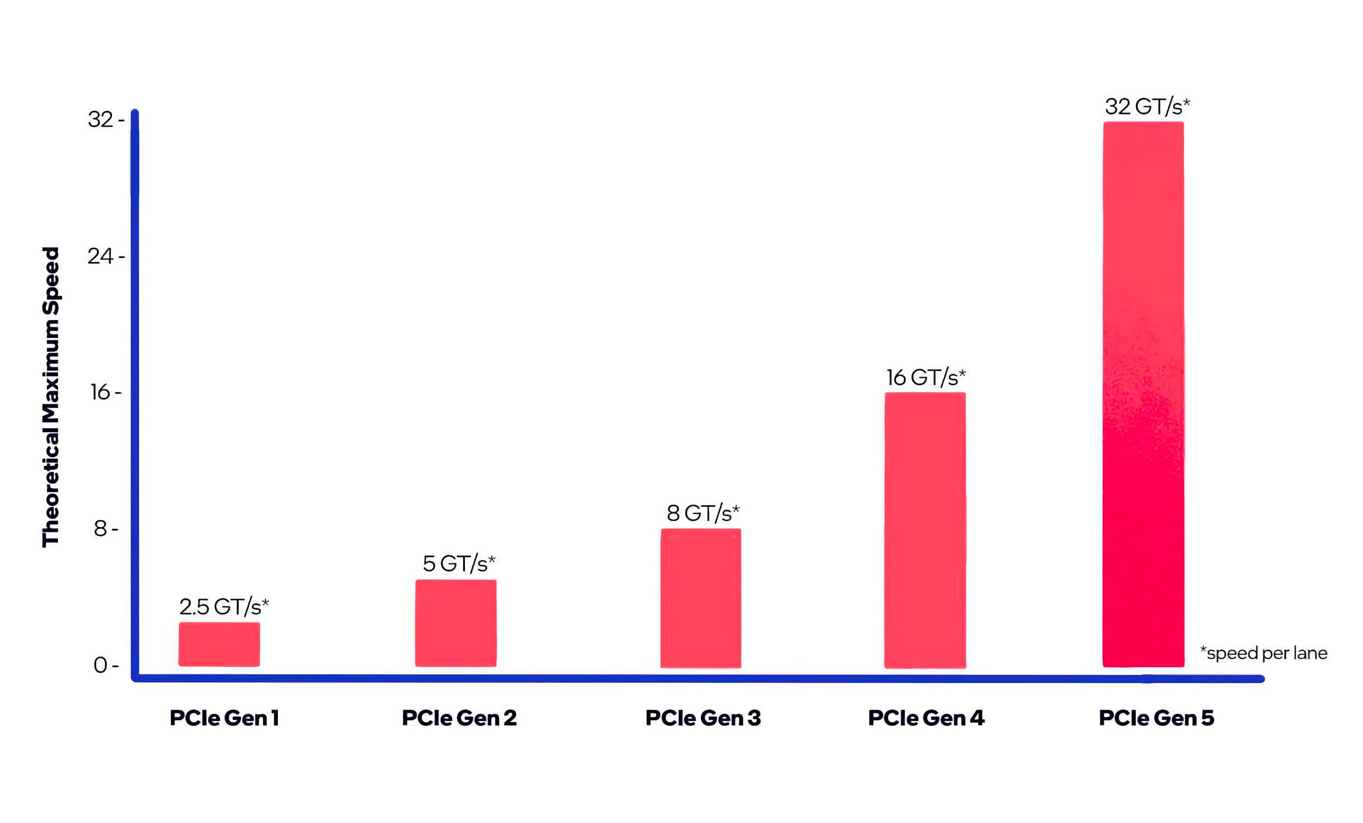

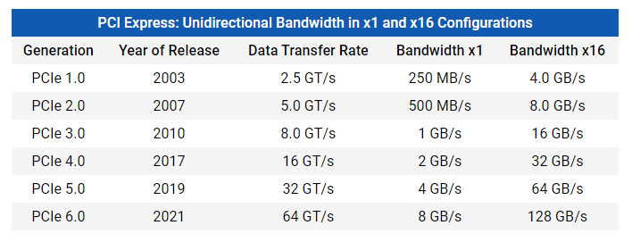

We benchmarked the 5500 XT in numerous configurations to get a sense of what this may entail for the 6500 XT. I first tested both the 4GB and 8GB models with their standard PCIe 4.0 x8 configuration, then performed the test with PCIe 4.0 x4 configuration. This is the same configuration as the 6500 XT, but with PCIe 3.0 x4 instead.

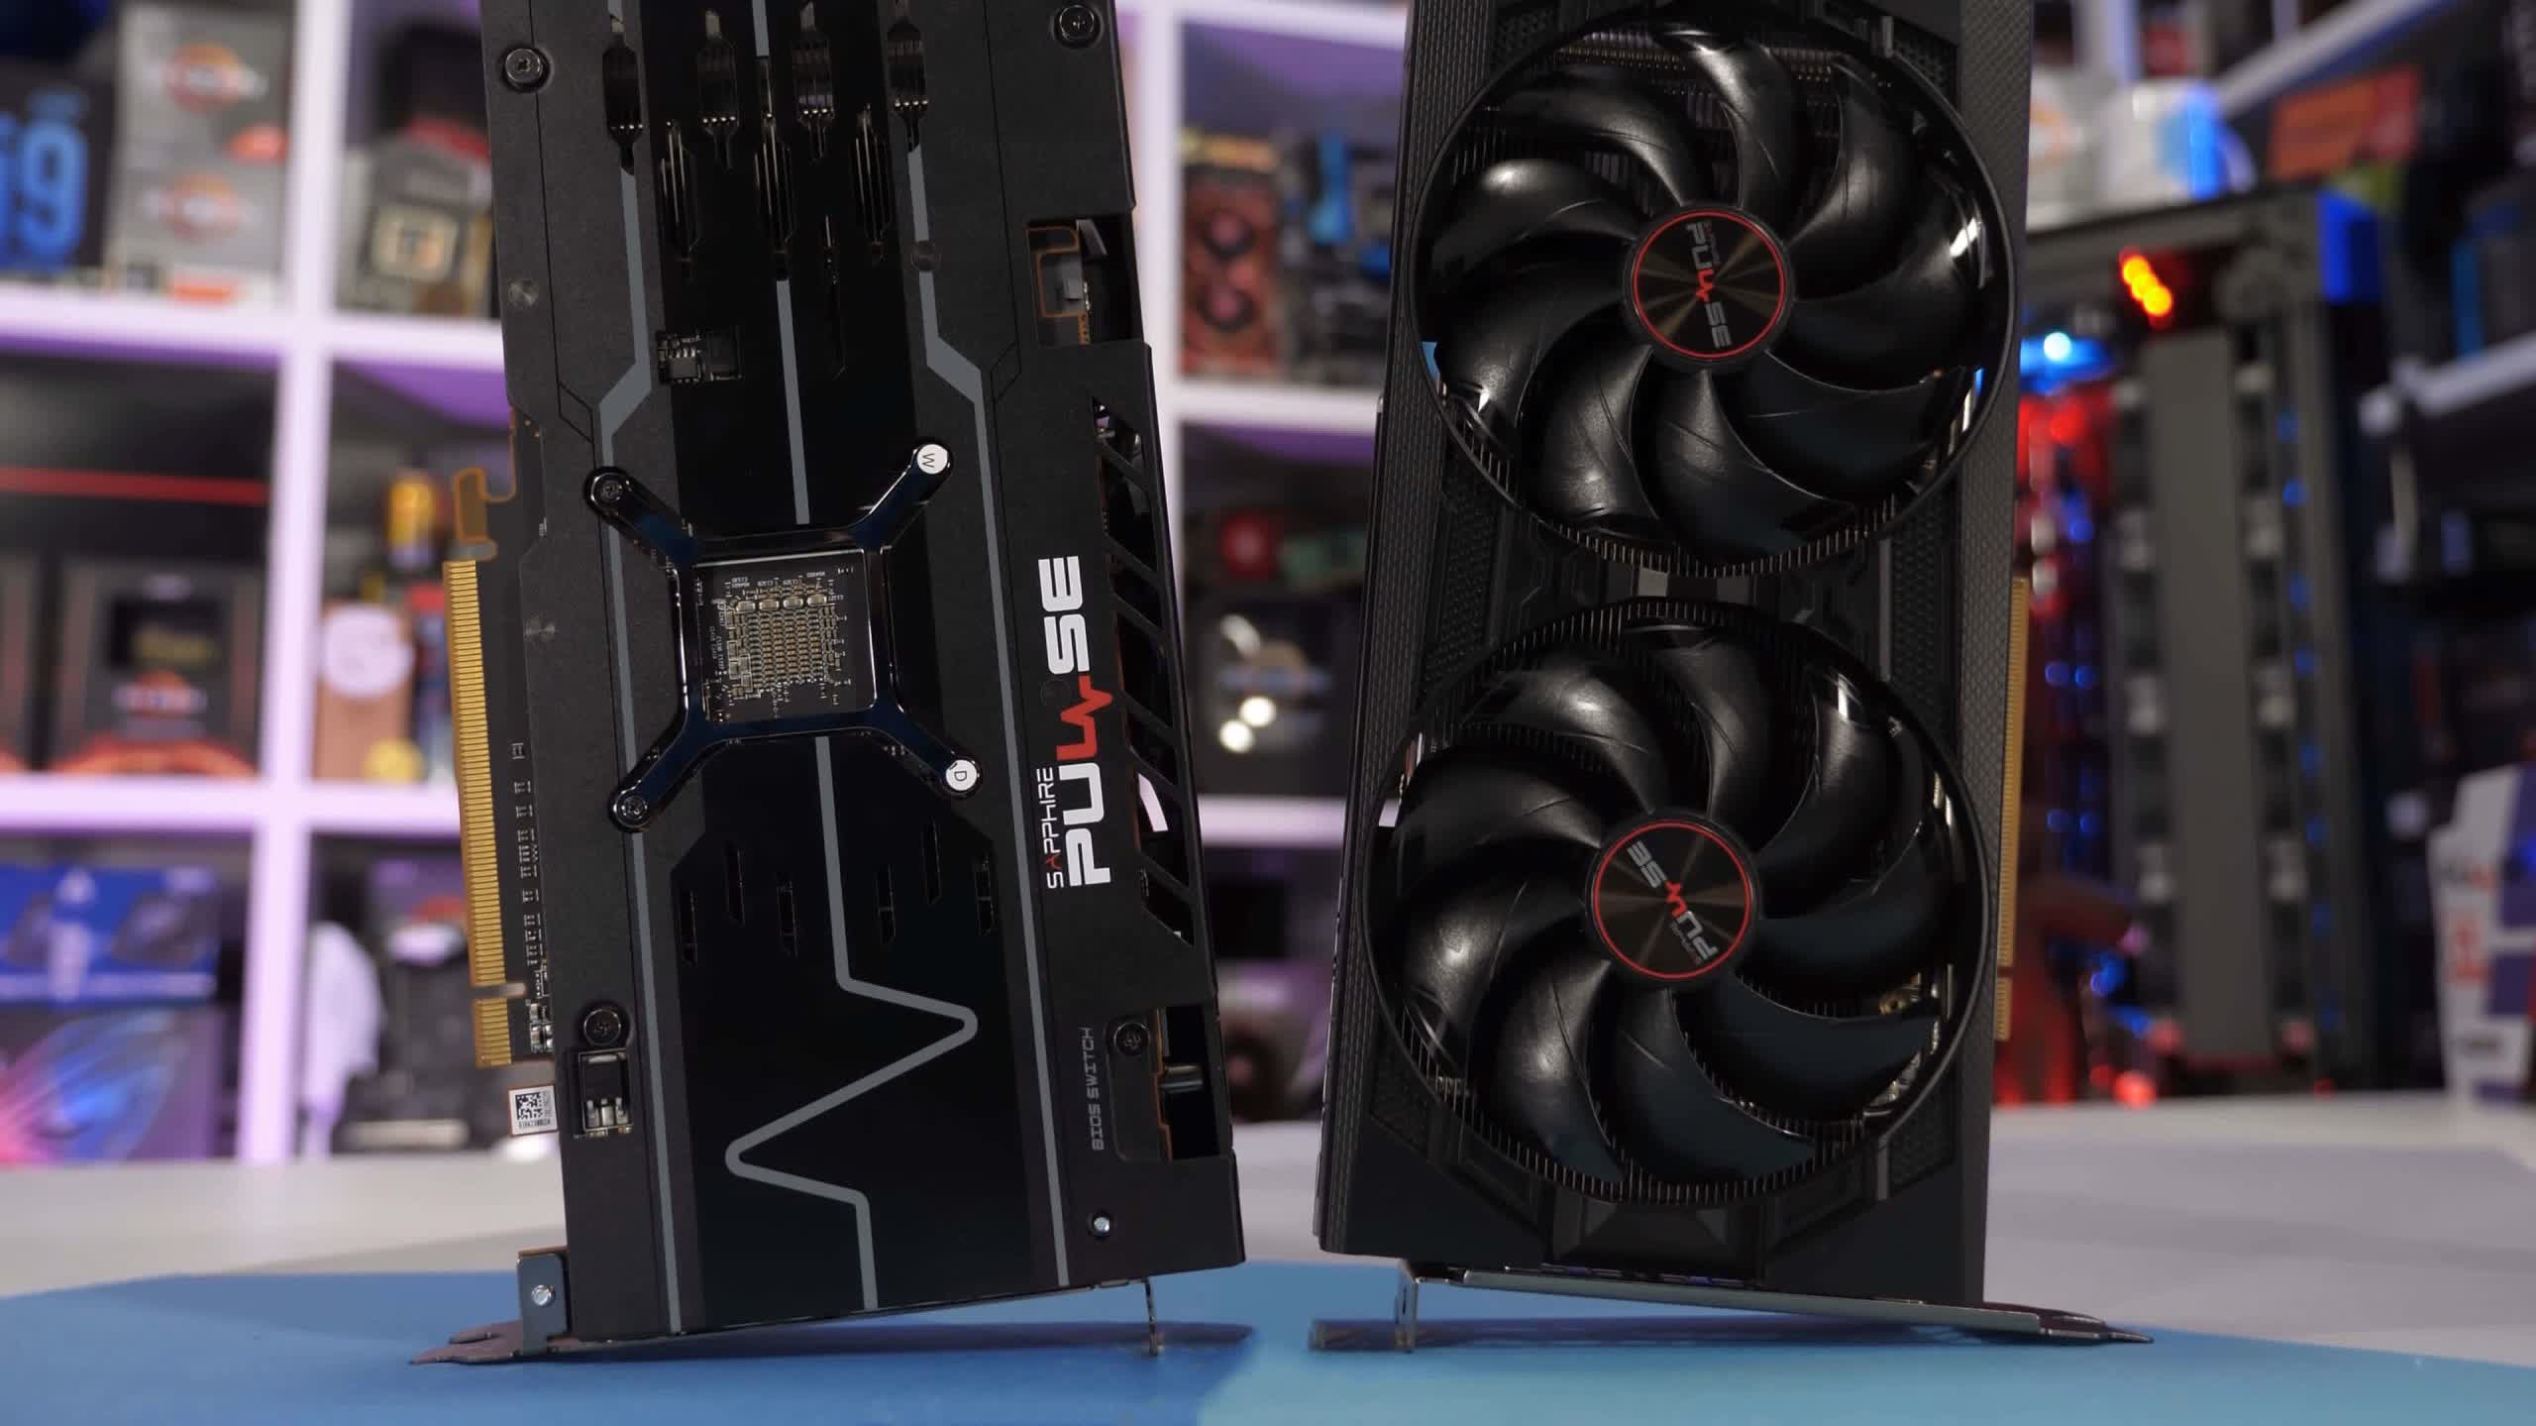

We've tested them in a dozen games at 1080p and 1440p, with the medium quality preset being a more realistic setting for this type of goods. We'll go over the data for the majority of the games we evaluated before comparing them side by side. Changing the PCIe mode in the BIOS was used to evaluate our Ryzen 9 5950X test setup.

Given that the 6500 XT and 5500 XT are predicted to have similar performance based on AMD's test statistics, utilising the 5500 XT to replicate the 6500 XT's probable PCIe difficulties should be quite realistic. We'll point out that the 6500 XT is built on the more contemporary RDNA2 architecture, which may assist ease some of the PCIe bandwidth concerns. While I don't anticipate this to be the case, we'll keep the architectural difference in mind.

**Benchmarks**

With the 8GB 5500 XT, we notice that reducing PCIe bandwidth has minimal to no effect on performance starting with F1 2021. When comparing the standard PCIe 4.0 x8 configuration of the 5500 XT to PCIe 3.0 x4, we notice a 9 percent drop in 1 percent low performance and a 6 percent impact to the average frame rate for the 4GB variant.

That's not a huge performance reduction, but it's still a decent decline for a device that wasn't particularly powerful to begin with, even if it works well in F1 2021 when using the high quality preset.

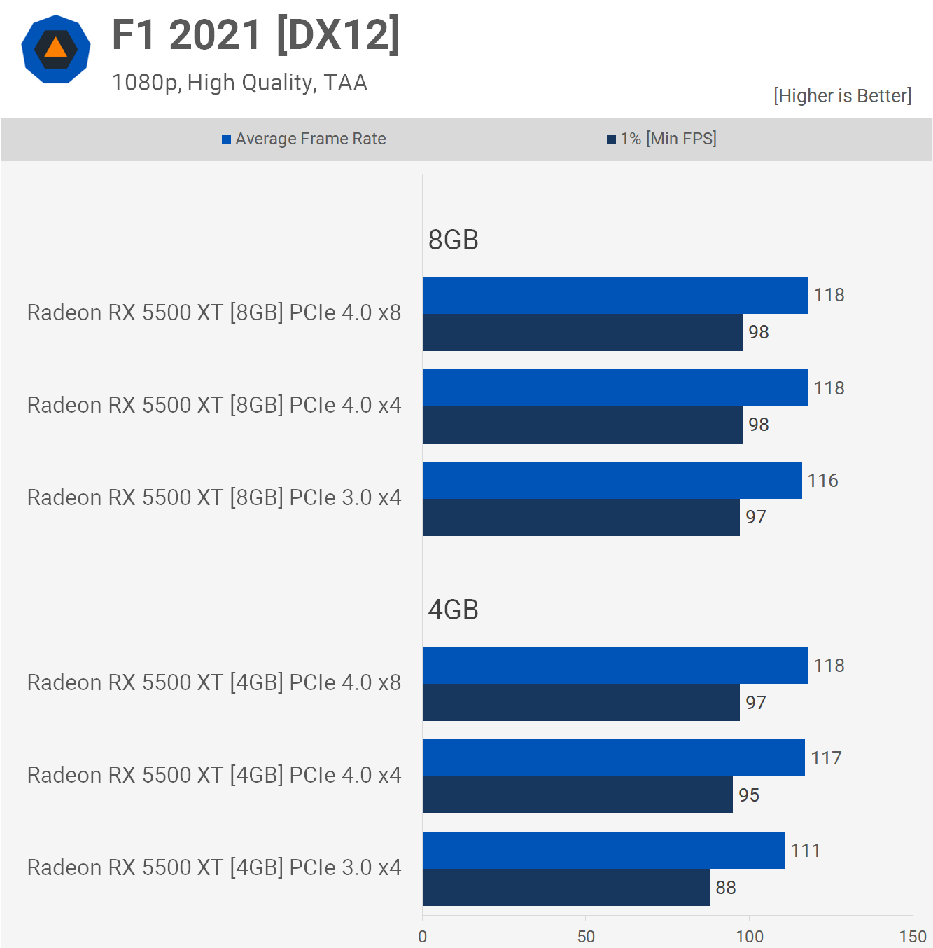

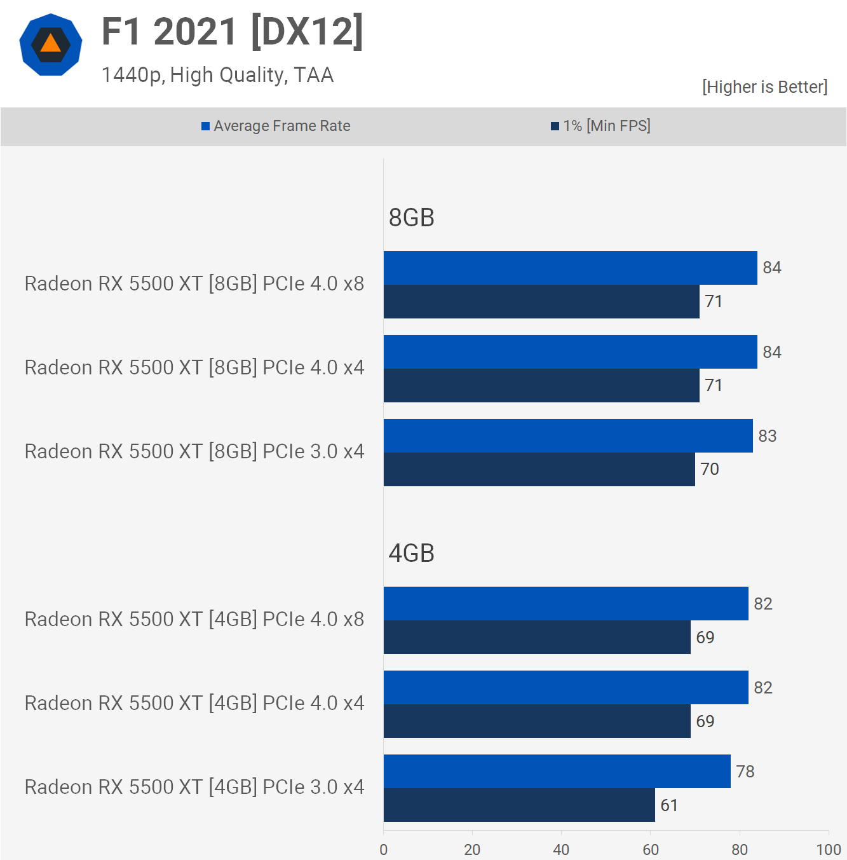

When we increase the resolution to 1440p, the 8GB model maintains its performance, however the 4GB device loses 12% of its former performance. In the big scheme of things, this isn't a major loss, and the game was completely playable, but for a card that doesn't exactly have heaps of computational power, a double-digit performance hit is bound to raise an eyebrow.

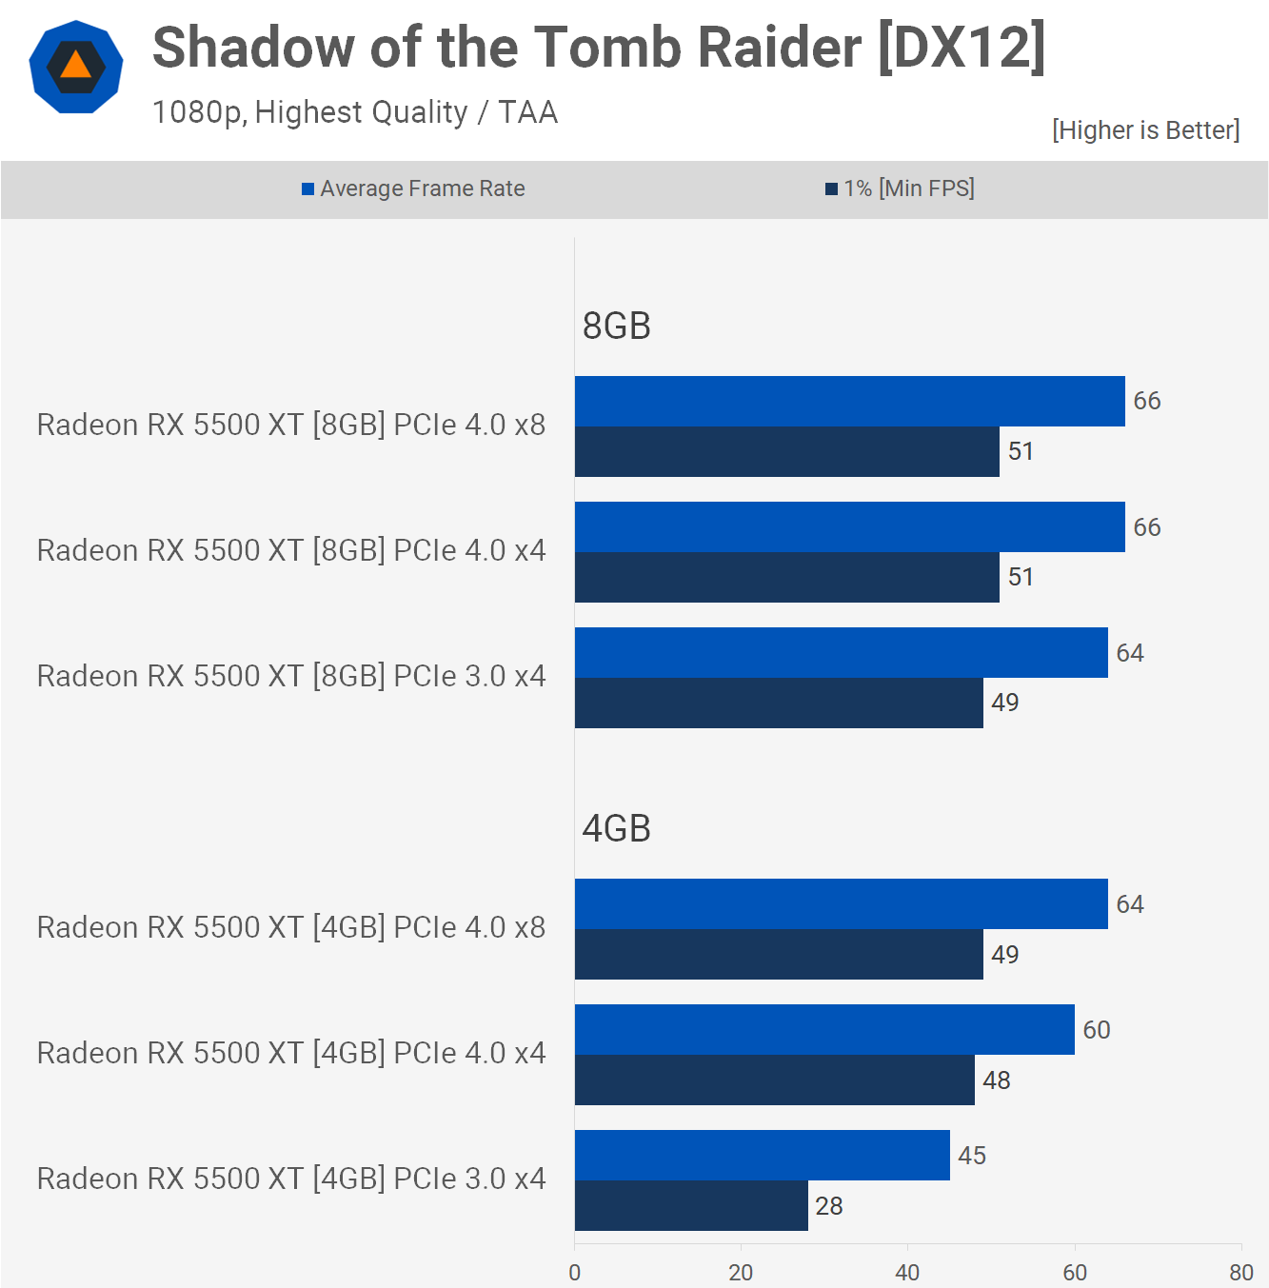

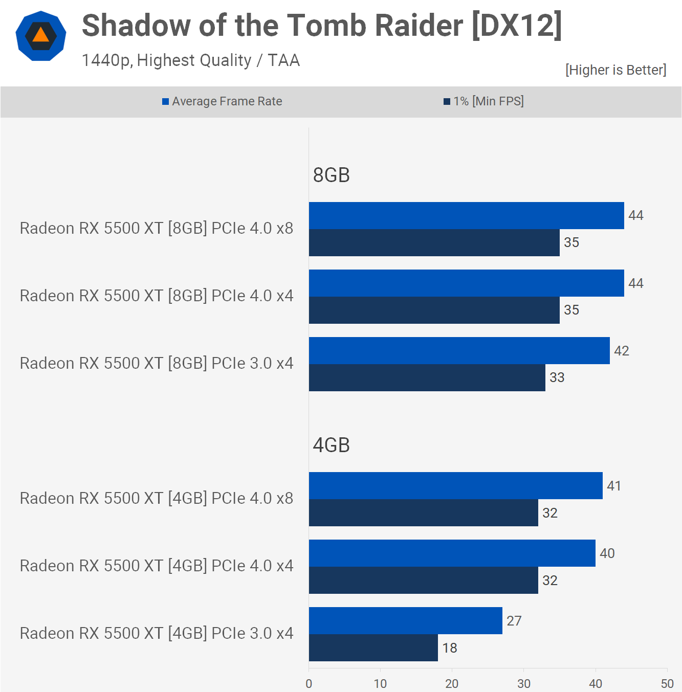

In Shadow of the Tomb Raider, things become a lot worse. A couple of things to keep in mind here: while we're utilising the highest quality preset for this game, it was launched in 2018, and with enough PCI Express bandwidth, the 5500 XT can easily drive 60 frames per second on average, resulting in a fun and playable experience.

We can see that the PCIe bandwidth issue is much less for the 8GB model. This is because the game allocates up to 7GB of VRAM when playing at 1080p.

The 4GB 5500XT runs well with its stock PCIe4.0 x8 configuration. There were no lag spikes and the game was extremely playable. Although we saw a 6% decrease in performance when using PCIe 2.0 x4 bandwidth, the gameplay was the same as the x8 configuration. Performance drops to PCIe 3.0 and, while technically still playable, frame suffering is common. The overall experience is very poor.

When comparing PCIe 3.0 operation to 4.0, we see a 43% decrease in 1% low performance on the 4GB model. This is an astonishing performance drop.

It's possible to argue that we are exceeding the VRAM buffer, so it's not realistic. However, I'm sure you won't be able to convince me otherwise, considering how well the game ran on PCIe 4.0x8.

Jumping up to 1440p did not help. We still see a 43% drop to the 1% lowests. The 4GB model still delivered playable performance when using PCI Express 4.0, but PCIe 3.0 made it impossible to play the game.

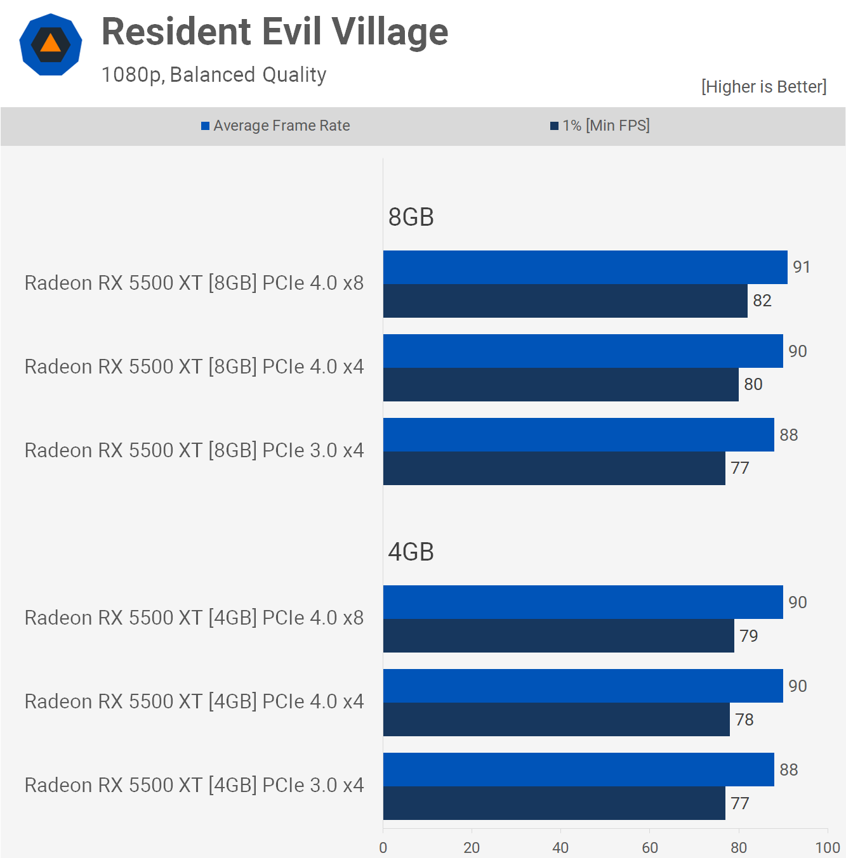

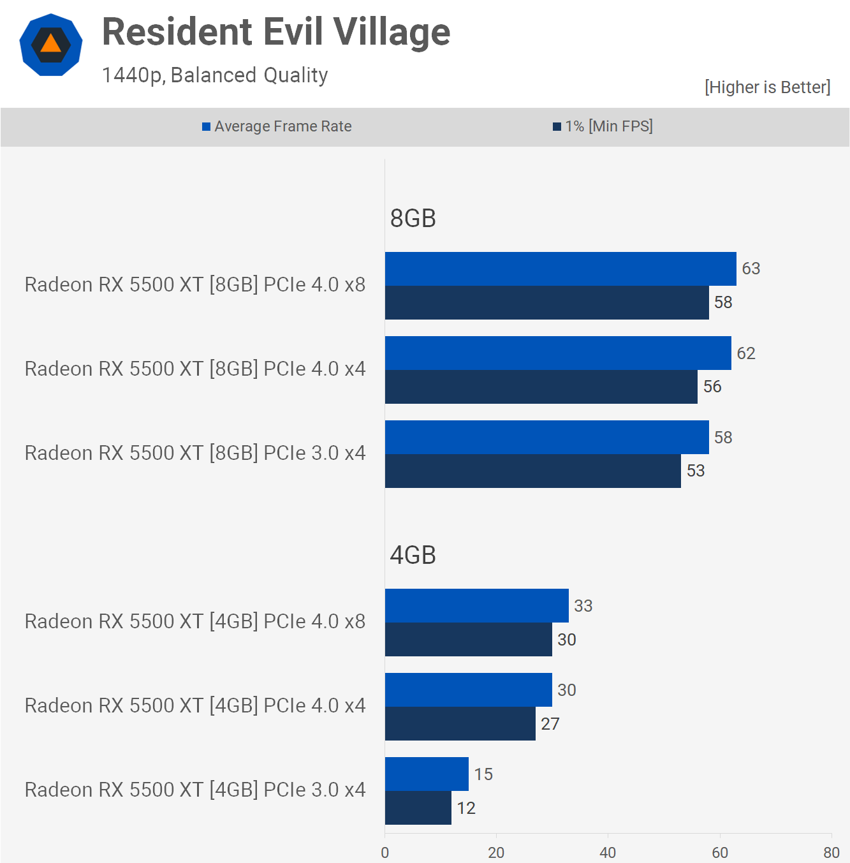

In our test, Resident Evil Village only used 3.4 GB of VRAM, thus this is a fantastic illustration of how well these cards work when kept in the memory buffer. We're using the significantly toned down 'balanced' quality preset, so anyone aiming for 60 fps on average for these single-player games will have some leeway to increase the quality settings, however as we've seen, performance concerns arise much more quickly when utilising PCIe 3.0 with an x4 card.

In fact, we have a nice example of this at 1440p, which drove RAM allocation up to 4.8 GB in our test, with consumption hovering around 4 GB. Aside from PCI Express bandwidth, the 5500 XT was limited by the 4GB buffer alone, and decreasing the bandwidth to x4 ruins performance to the point that the card can no longer be utilised.

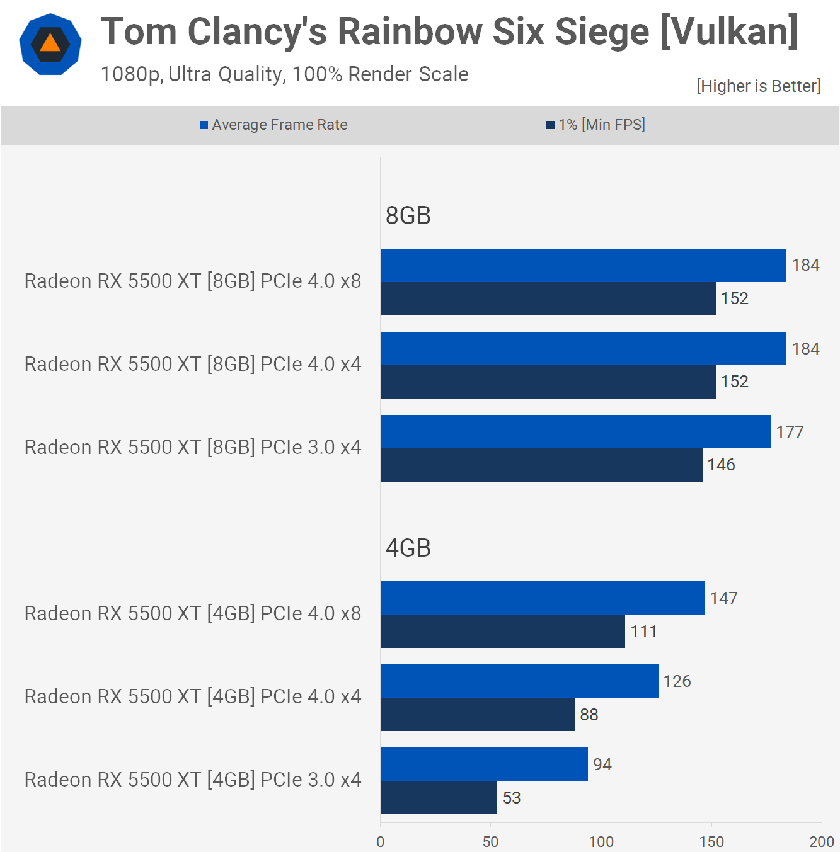

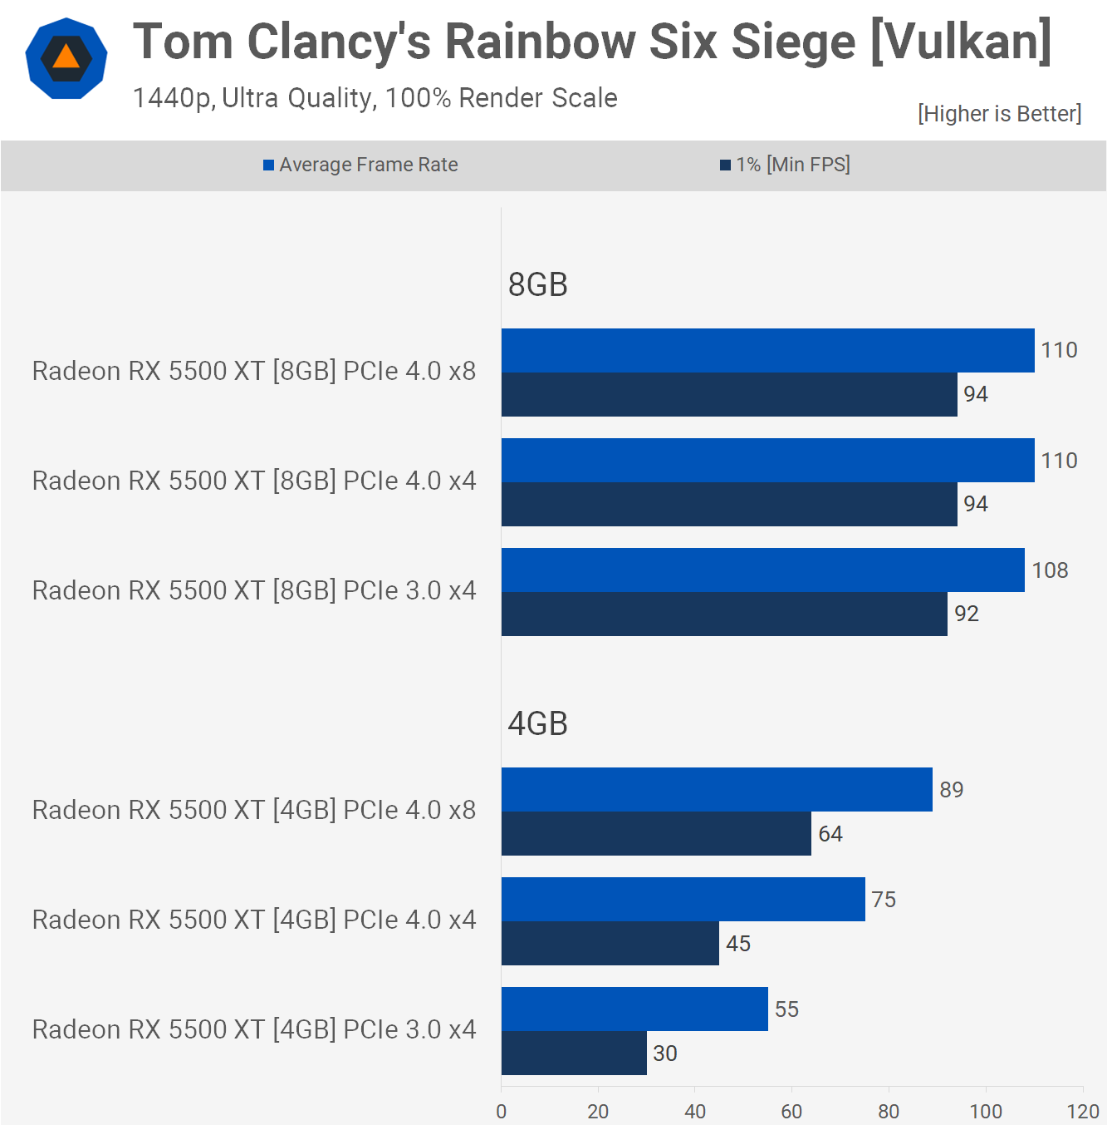

Rainbow Six Siege is yet another example of why severely limiting PCI Express bandwidth for cards with smaller VRAM buffers can be a bad idea. The 4GB 5500XT is already 27% faster than the 8GB model, the only difference being the VRAM capacity.

We find that the 4GB model suffers from a serious performance problem due to the limitation of PCIe bandwidth. The 1% drop in bandwidth by halving it from x8-x4 in 4.0 mode is 21%. This is especially interesting because it could indicate that the 6500 XT still suffers from hemorhaging performance because of the x4 bandwidth.

It gets worse for PCIe 3.0 users, who are most likely to be looking for a budget GPU. This is a 52% decrease in performance from the 4.0x8 configuration to the 3.0x4. Worse, 1% lows do not drop below 60 frames per second. While this can be fixed by decreasing the quality settings, it was still perfectly playable with 4GB VRAM using the PCIe mode 4.0x8.

It's the same as expected at 1440p. However, the 1% lows are cut in half when you use PCI Express 3.0.

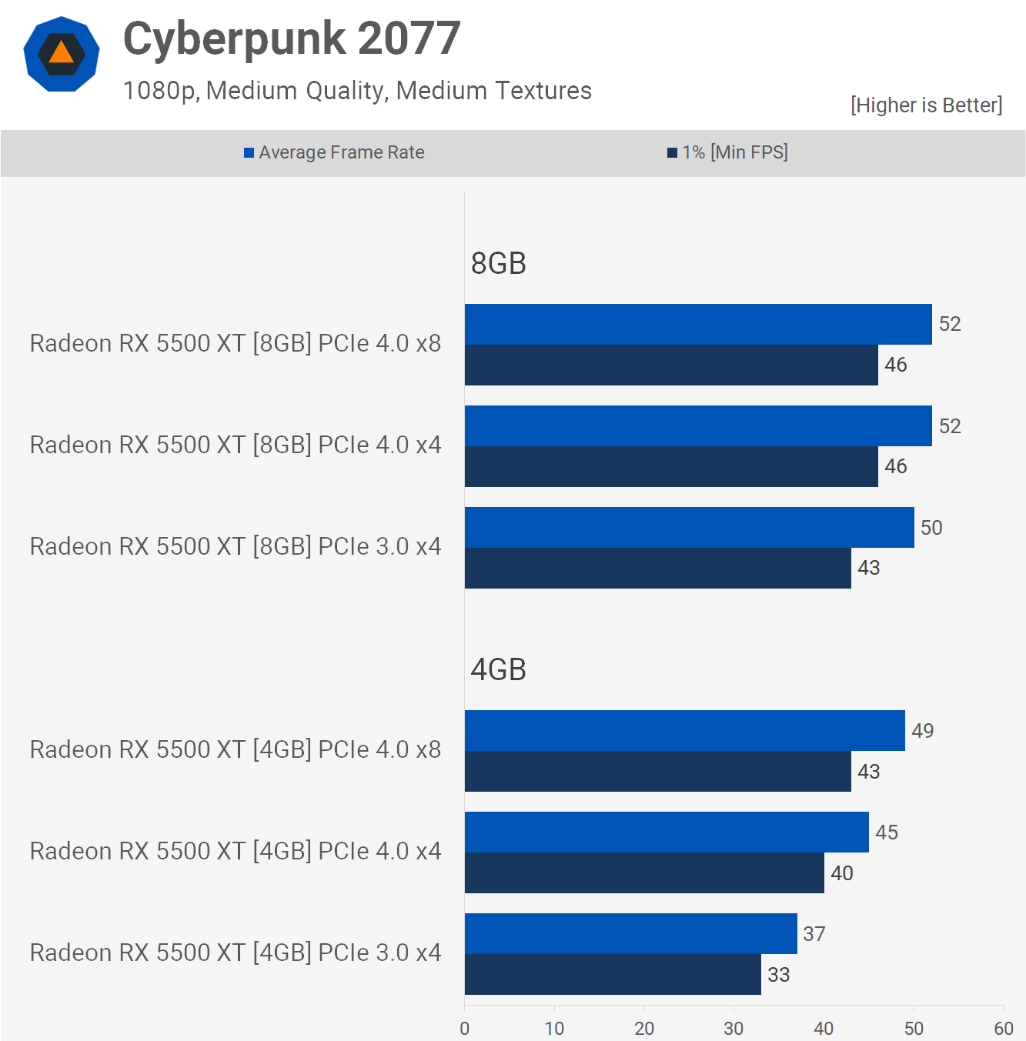

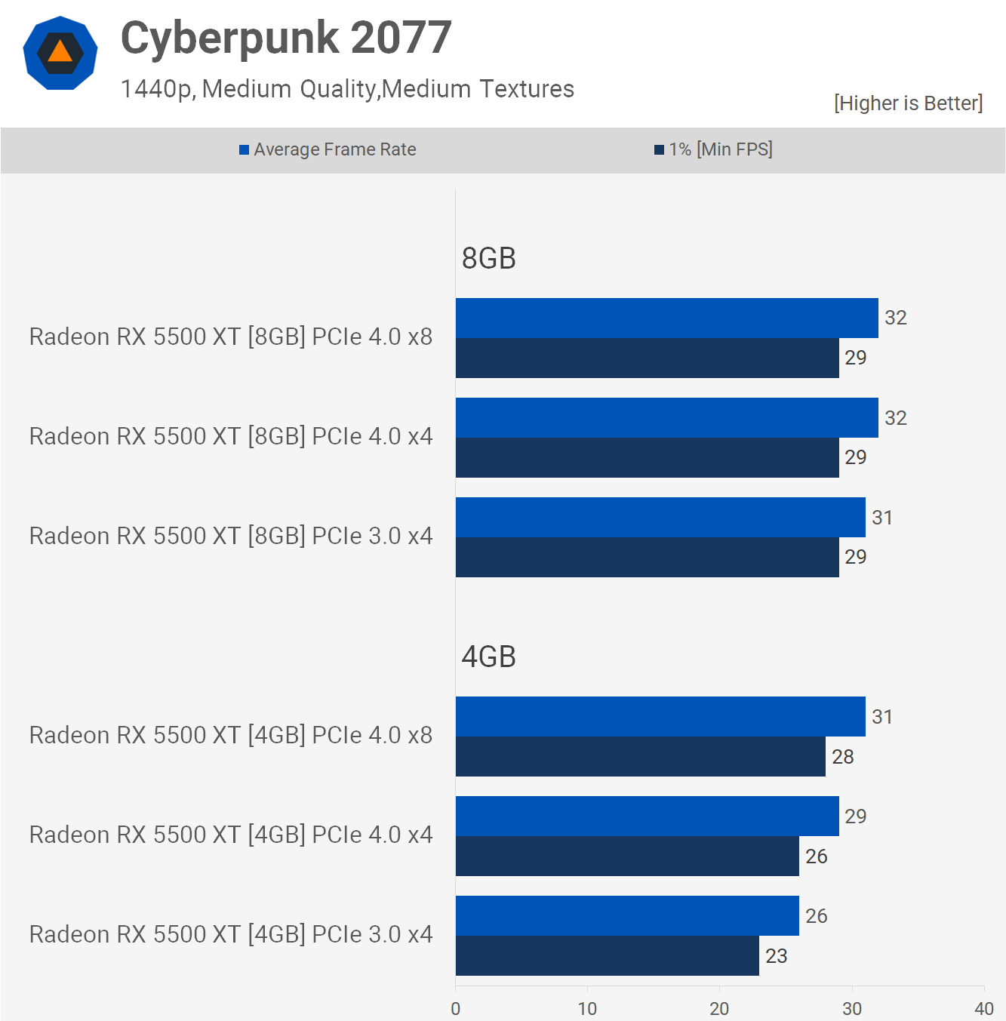

Moving on to Cyberpunk 2077, we used the medium quality preset with medium quality textures to see how it worked. Even with these settings, this game is quite demanding, yet the 4GB 5500 XT was able to give playable performance with an average of 49 fps at 1080p in full PCIe 4.0 x8 mode. When the bus bandwidth was reduced to PCIe 3.0 x4, performance dropped by 24%, and the game is now hardly playable.

The 1440p data isn't really useful because you can't play Cyberpunk 2077 at this resolution with the medium quality settings on a 5500 XT, but it's included for completeness' sake.

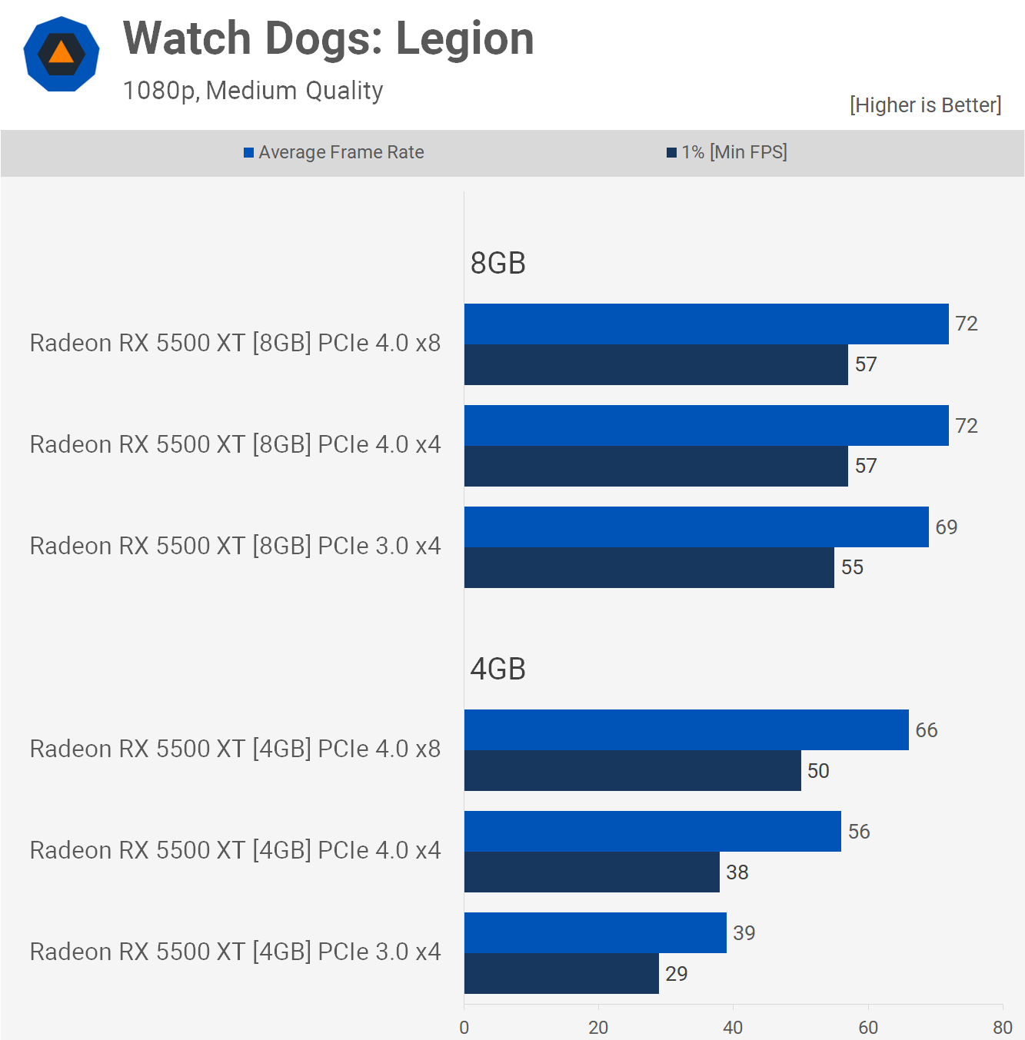

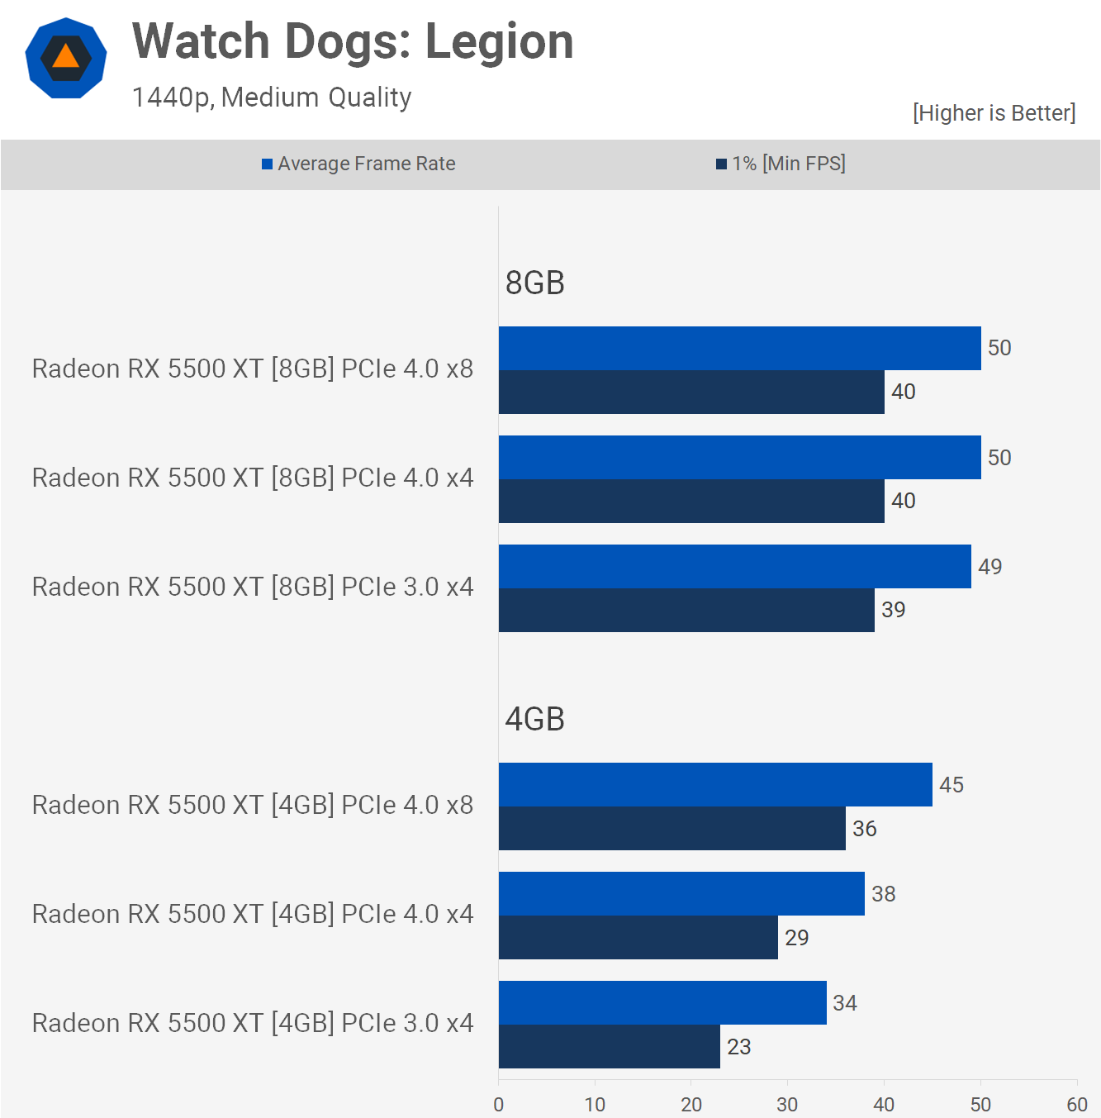

Watch Dogs Legion was tested using the medium-quality preset. Although the 4GB model performed slower than the 8GB version, the game uses 4.5GB of memory. However, the standard PCIe configuration produced a decent performance with 66 frames per second on average. The game ran just fine, despite the fact that it was using system memory.

We find that PCIe 4.0x4 had a significant impact on performance. This is compared to PCIe 3.0x4 which dropped performance by 24% and then ruined it by 42%.

According to reports, the 6500XT will be a poor performer. The 4GB buffer and the PCIe 4.0x4 bandwidth are 100% of the reasons. We can see an example here at 1080p using the 5500XT.

Actually, the PCIe 3.0x4 mode looks better at 1440p than the 4.0 specification because the PCIe bandwidth bottleneck at this resolution is less severe that the compute bottleneck. However, this is still a 36% performance hit.

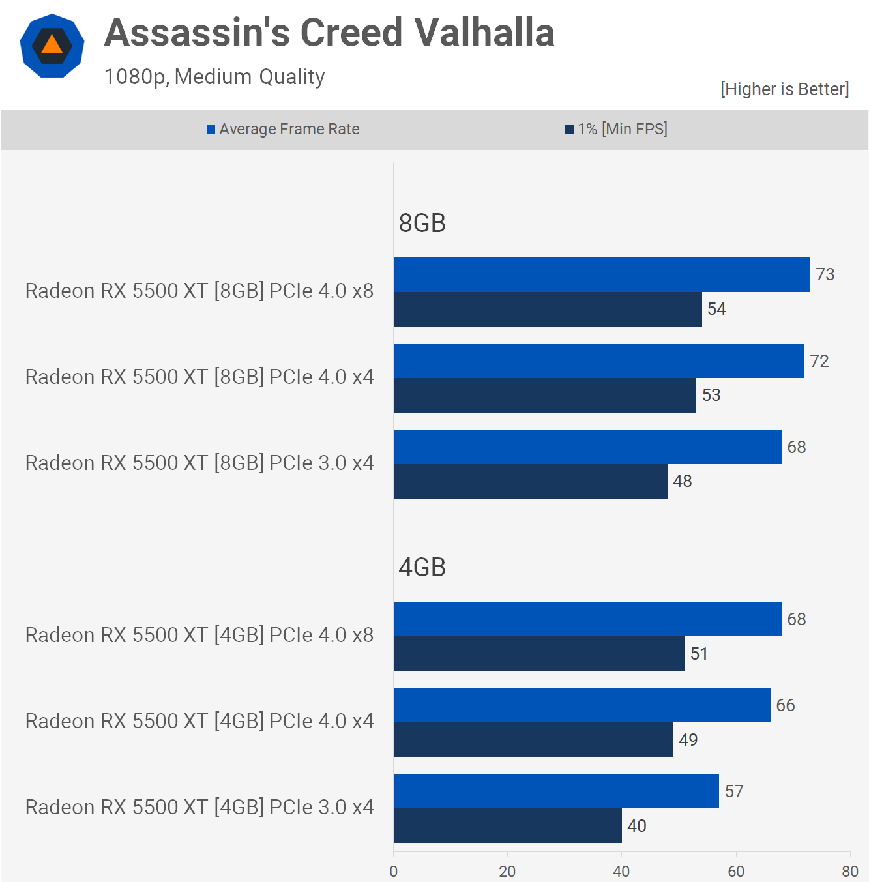

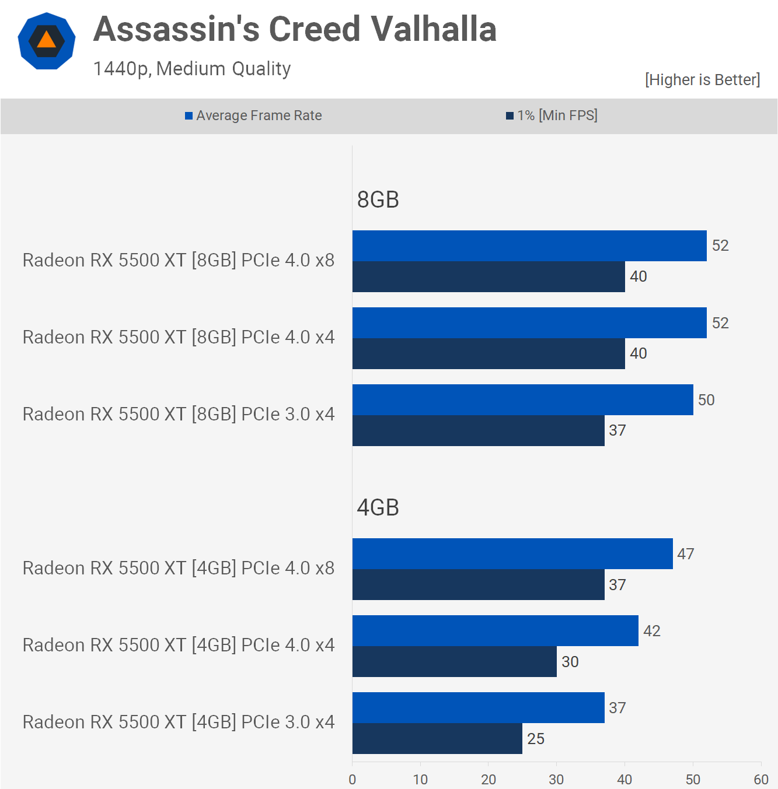

The medium quality preset was used to test Assassin's Creed Valhalla, and we saw an 11 percent performance impact for the 8GB variant while utilising PCIe 3.0 x4, which is surprising because the game only required up to 4.2 GB in our 1080p test.

As a result, the 4GB model suffered the most, with 1 percent lows plummeting by 22%, from 51 fps to barely 40 fps. The game could still be played, but it would have taken a significant performance impact on an already low-end graphics hardware.

At 1440p, the gaps continued to widen, and the PCIe 3.0 x4 setup for the 4GB model was now 32 percent slower than the PCIe 4.0 x8 option. That's an enormous margin, but it's more than simply numbers on a graph. When we were playing the game, the gap between these two was striking, as if we were comparing two completely distinct product levels.

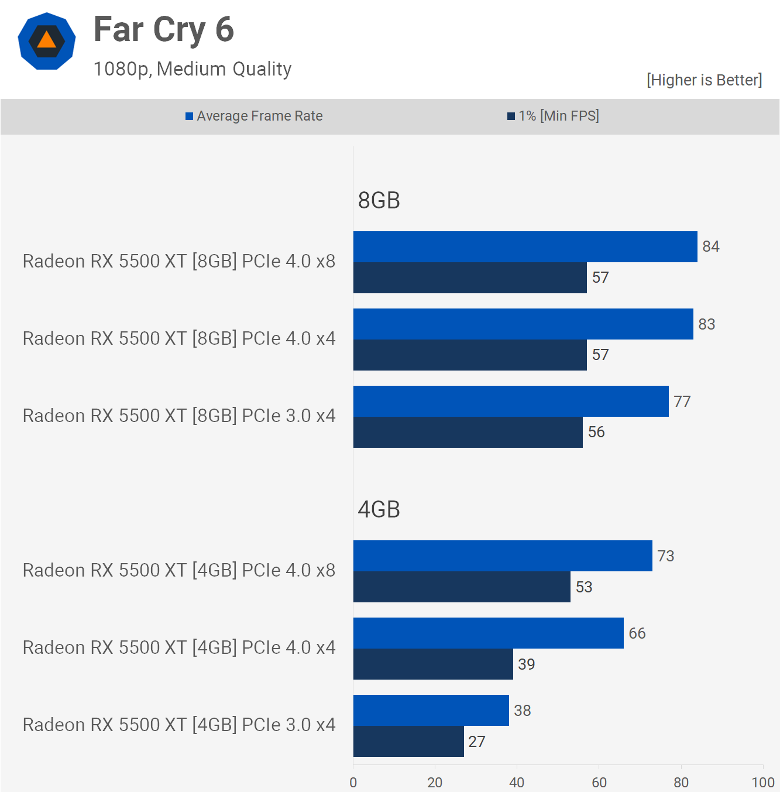

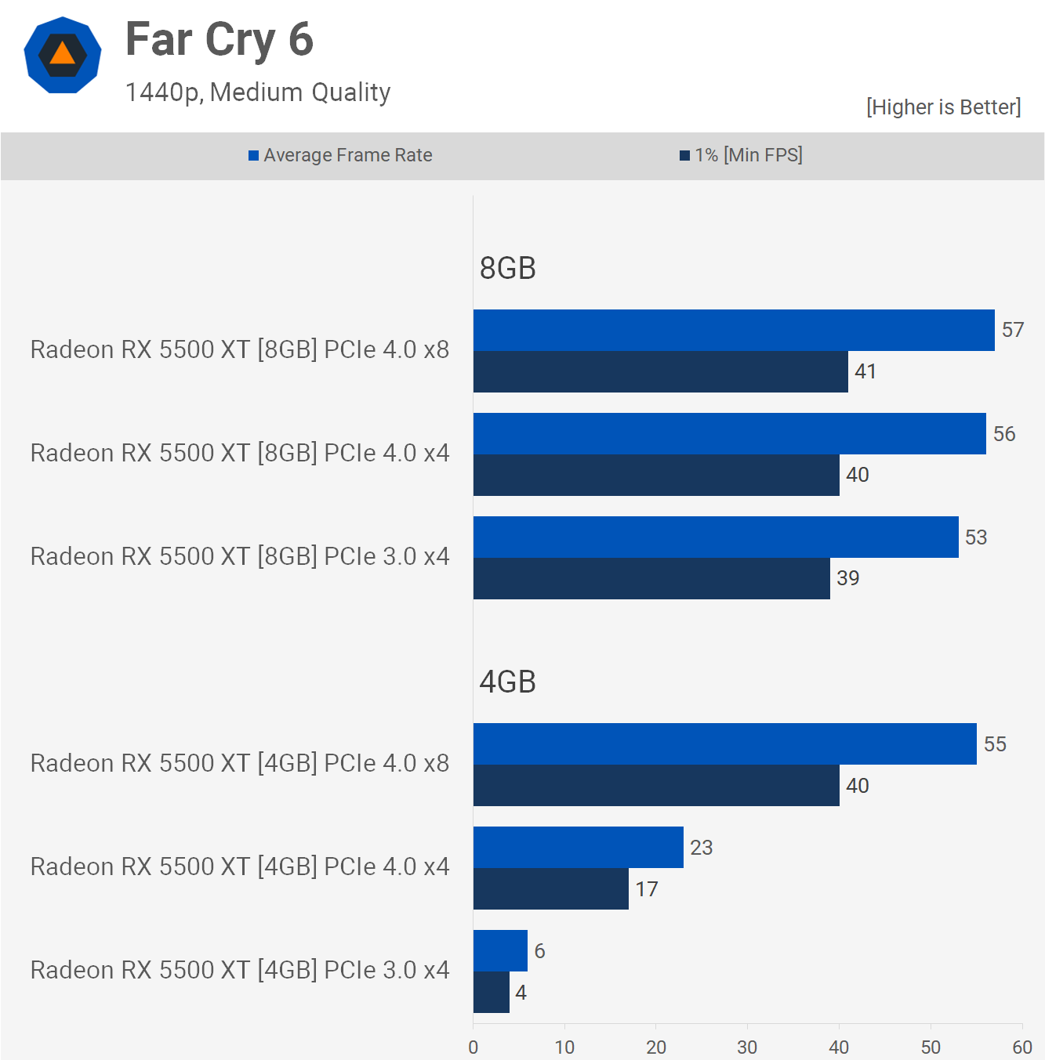

Watch Dogs Legion was tested using the medium-quality preset. Although the 4GB model performed slower than the 8GB version, the game uses 4.5GB of memory. However, the standard PCIe configuration produced a decent performance with 66 frames per second on average. The game ran just fine, despite the fact that it was using system memory.

We find that PCIe 4.0x4 had a significant impact on performance. This is compared to PCIe 3.0x4 which dropped performance by 24% and then ruined it by 42%.

According to reports, the 6500XT will be a poor performer. The 4GB buffer and the PCIe 4.0x4 bandwidth are 100% of the reasons. We can see an example here at 1080p using the 5500XT.

Actually, the PCIe 3.0x4 mode looks better at 1440p than the 4.0 specification because the PCIe bandwidth bottleneck at this resolution is less severe that the compute bottleneck. However, this is still a 36% performance hit.

Surprisingly, the 4GB 5500 XT performed OK at 1440p with full PCIe 4.0 x8 bandwidth, but was absolutely unusable below that. I would have thought that no matter how much PCIe bandwidth you fed it, performance would suffer, but evidently not.

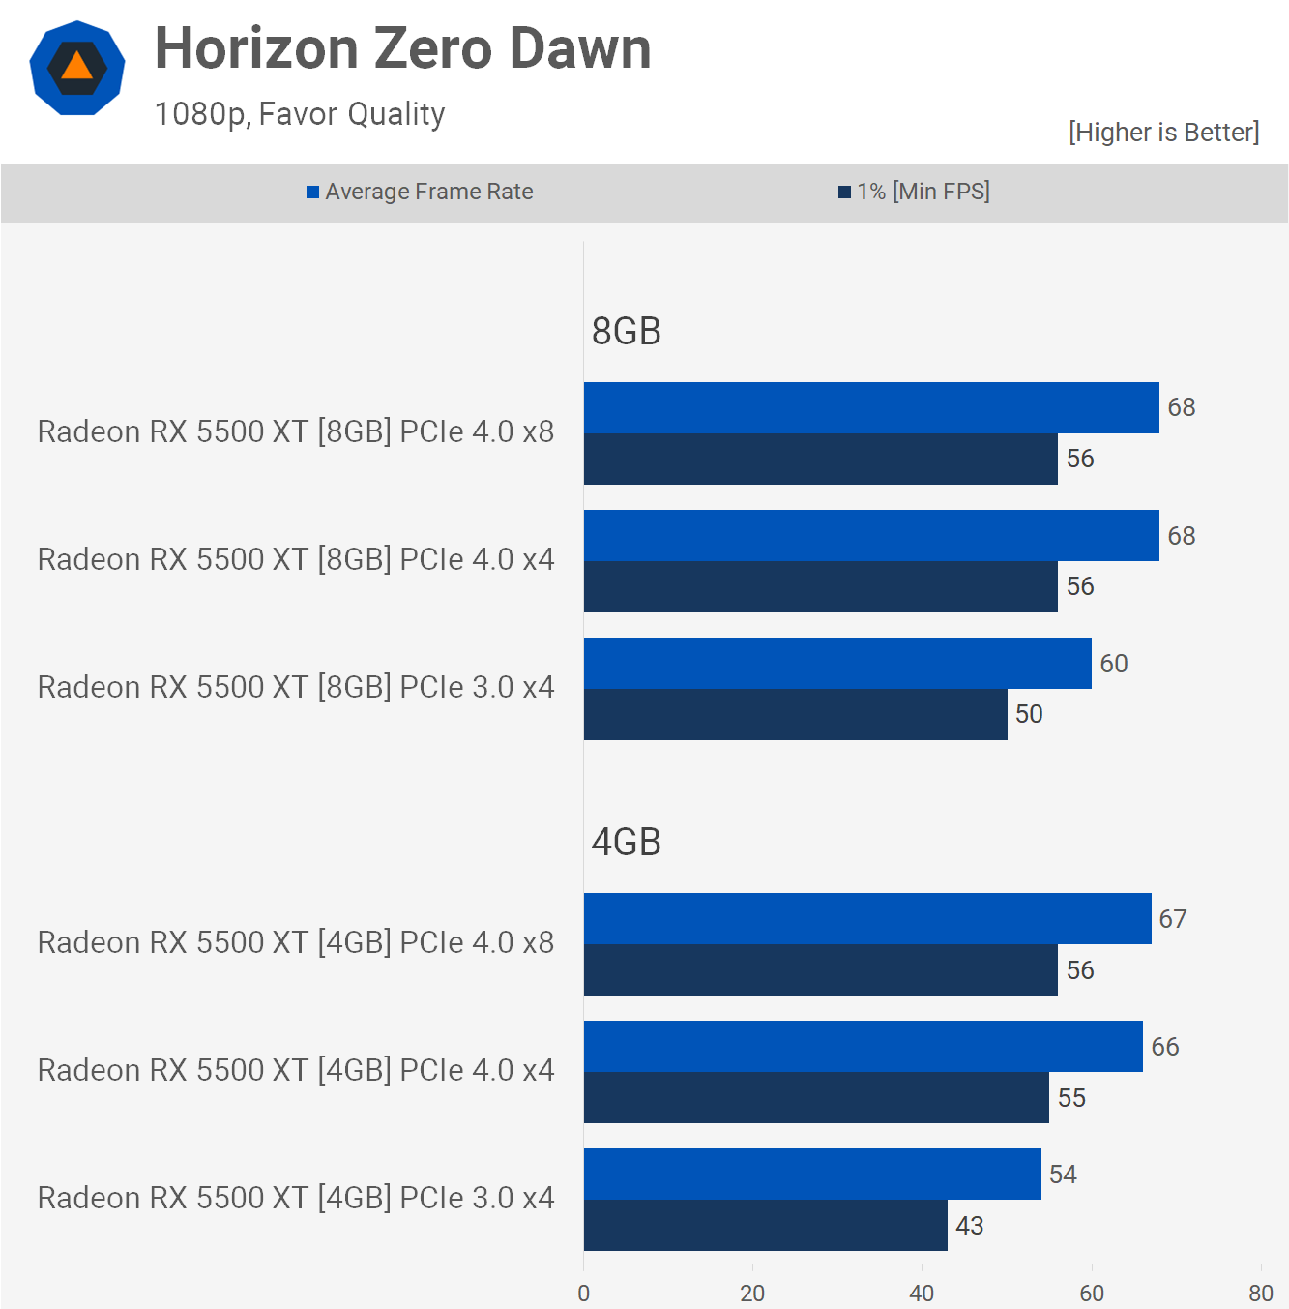

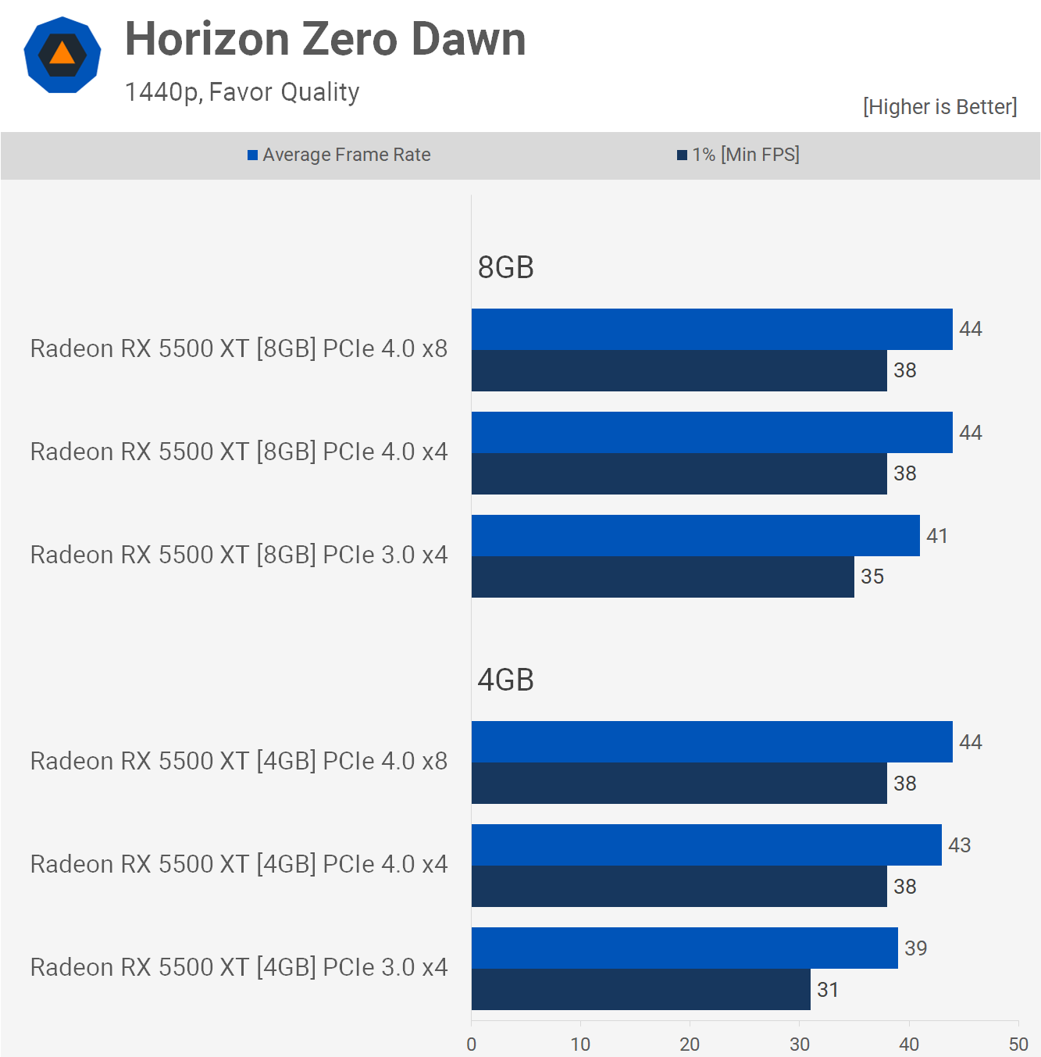

Horizon Zero Dawn needs 6.4 GB of VRAM @ 1080p using the 'preferred quality' option. Interestingly, while not exceeding the 8GB model's VRAM buffer, forcing PCIe 3.0 x4 operation resulted in an 11 percent performance drop. Then came the 4GB variant, which virtually quadrupled the margin to 23%. It's worth noting that both PCIe 4.0 setups performed similarly to the 8GB model, thus PCIe 3.0 is where things become sticky again.

The 1440p results are comparable, however we're constrained in terms of computation. Nonetheless, decreasing PCIe bandwidth has a significant impact on performance for both the 4GB and 8GB 5500 XT models.

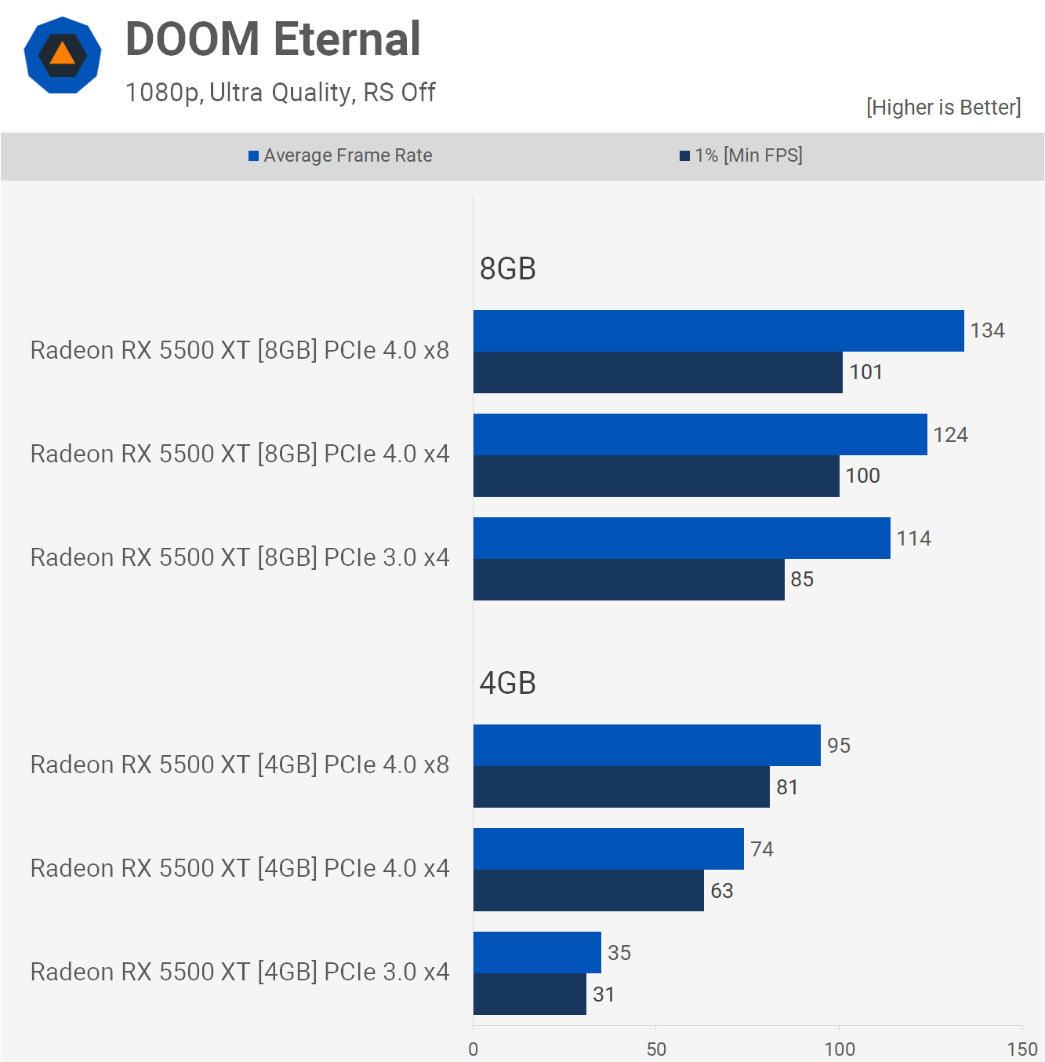

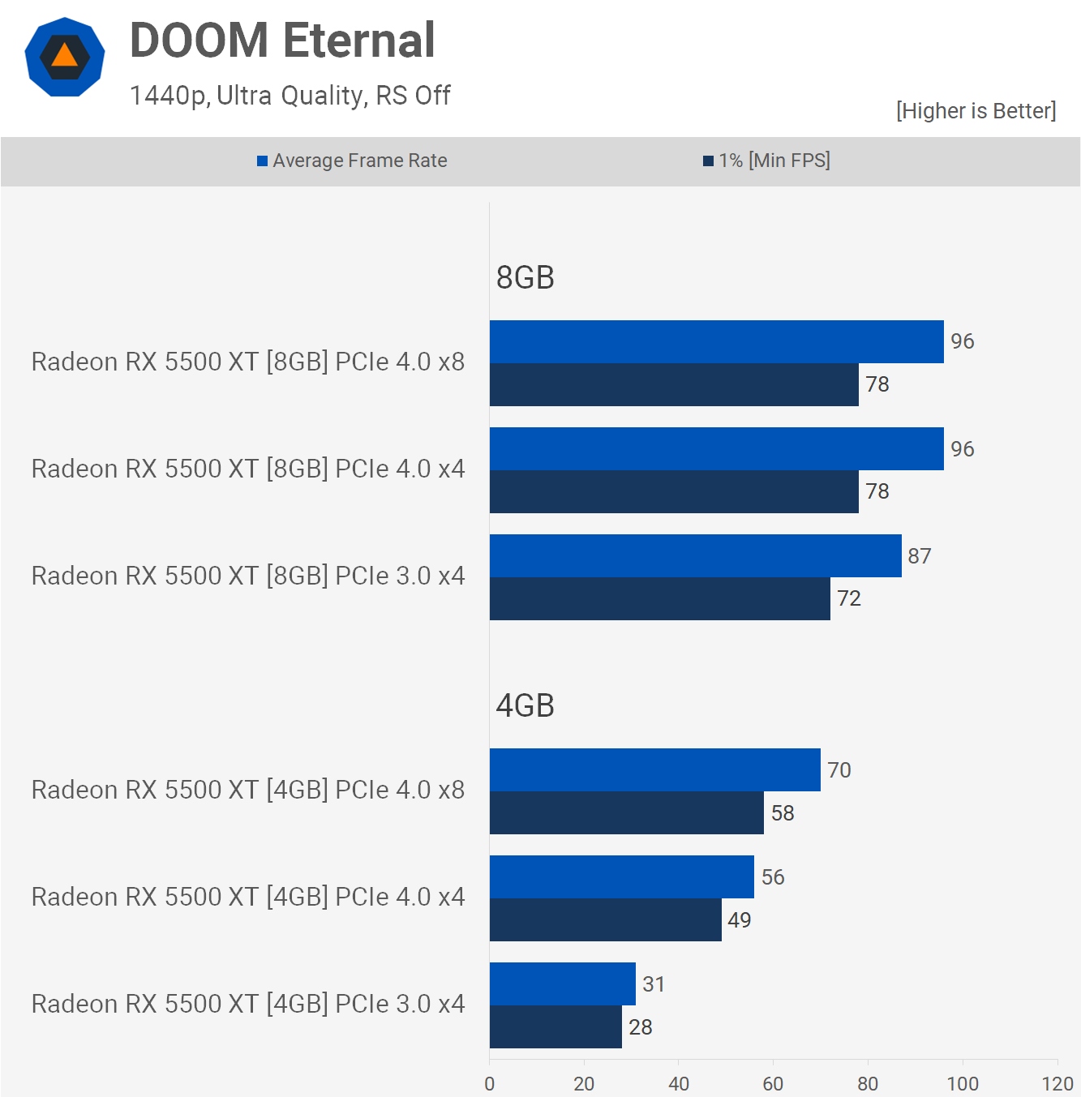

Doom Eternal is a fun game to play since it tries to keep the memory buffer from filling up by restricting the quality levels you may utilise. For both models, we utilised the extreme quality preset, but for the 4GB version, we had to lower the texture quality to medium before the game would let us apply the preset.

In our test scene, the game used up to 5.6GB of VRAM at 1080p. This figure was reduced to 4.1GB by dropping the texture pool size from'medium to 'large'. The 8GB 5500XT has VRAM usage of 5.6GB, while the 4GB model is at its maximum, with the game using 4.1GB if it was available.

The 4GB 5500XT still runs 29% slower than its 8GB counterpart when it is using PCIe4.0x8. The 8GB model's PCIe bandwidth was reduced by 1%, which resulted in a drop of performance as high as 16%.

The 4GB version was where things got really bad. Performance was hampered by 22% reductions in PCIe bandwidth, from 4.0x8 to 4.0x4. It was then switched to 3.0, rendering the game unplayable at 35 frames per second.

Although the margins increased slightly at 1440p overall, the results were almost identical. Assuming that the 6500 XT behaves in a similar way to the 5500 XT at 1440p, it will be much more financially troubled than the parts of the 8GB 5500 XT. It will also be completely disabled in PCIe 3.0 systems.

**Average Frame Rates**

Below is a breakdown of the 12 games we tested. We didn't bother with Death Stranding and Hitman 3 because the results were not interesting.

This comparison shows the average frame rate for the 4GB 5500XT using PCIe4.0 x8. This is the default configuration of that model. It's also compared to PCIe3.0 x4. We see a 49% improvement in performance with PCIe 4.0x8, and Doom shows a 171% increase. Resident Evil Village was the best case, although it was only one time in our testing.

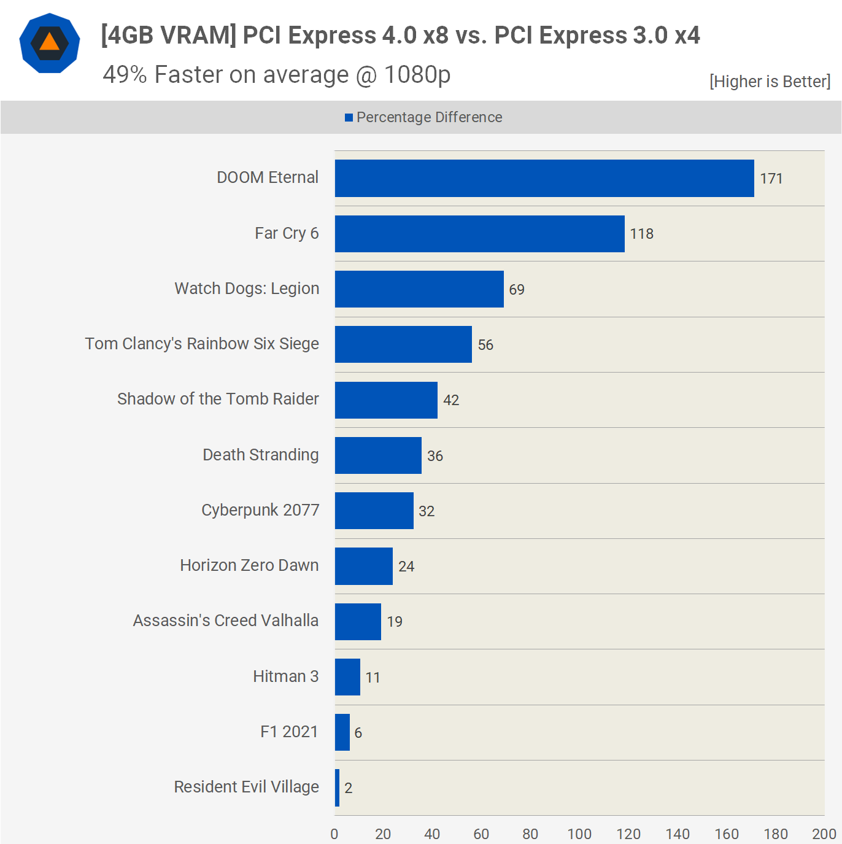

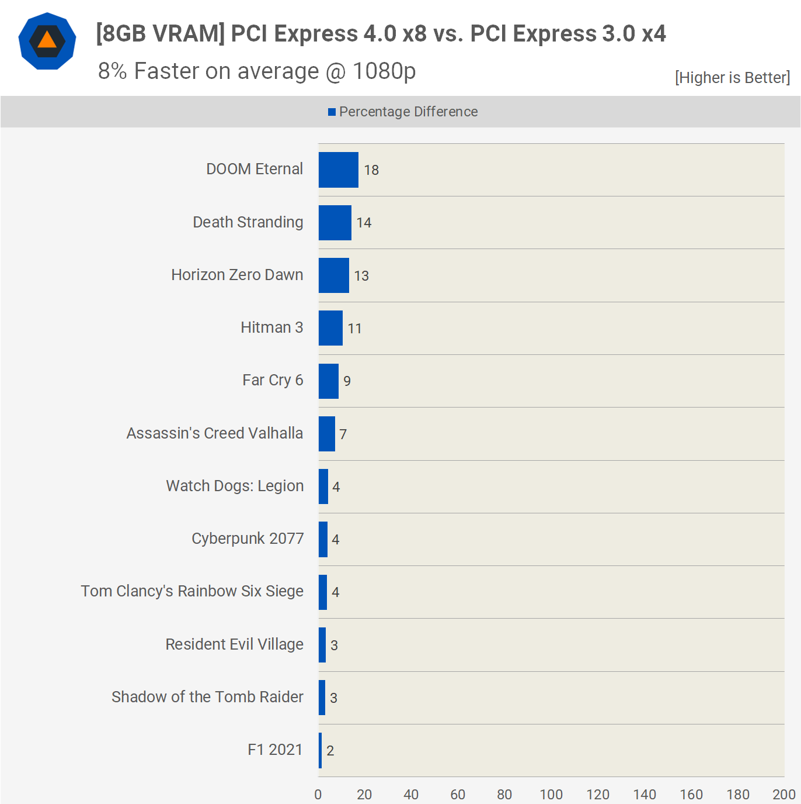

Even F1 2021 saw a 6% decrease, but that's a best-case scenario. Beyond that, we're looking at double-digit increases, with well over half of the games showing boosts of more than 20%, and keep in mind that we're mostly utilising medium-quality settings.

Now, if we normalise the X axis and use the 8GB model, we can see how minimal the performance difference is between PCIe 4.0 x8 and PCIe 3.0 x4. Although the added bandwidth has resulted in some significant speed benefits, the bigger VRAM buffer has helped decrease inconsistencies, resulting in just an 8% boost on average.

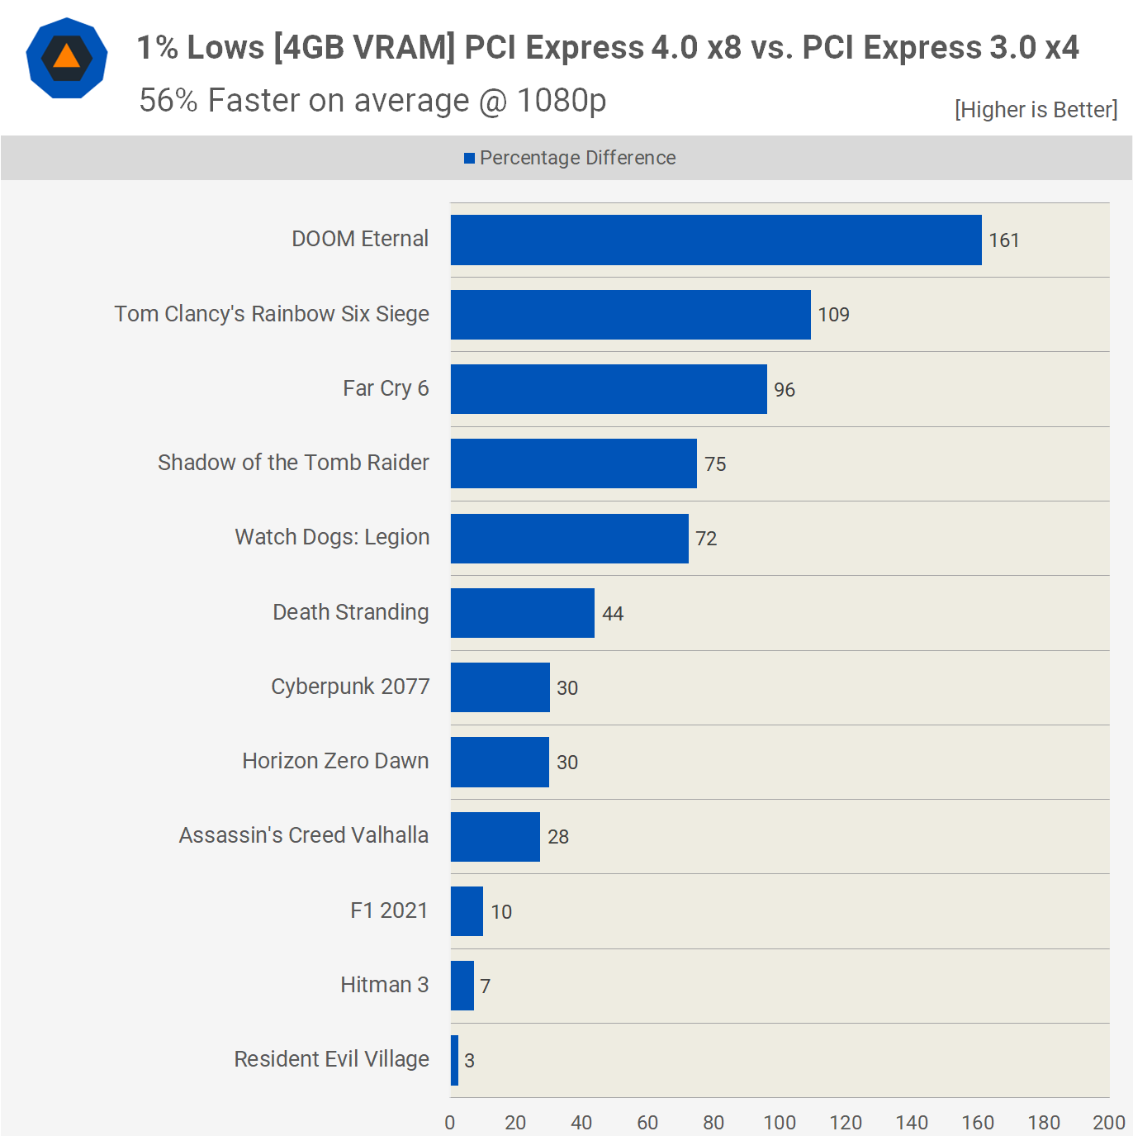

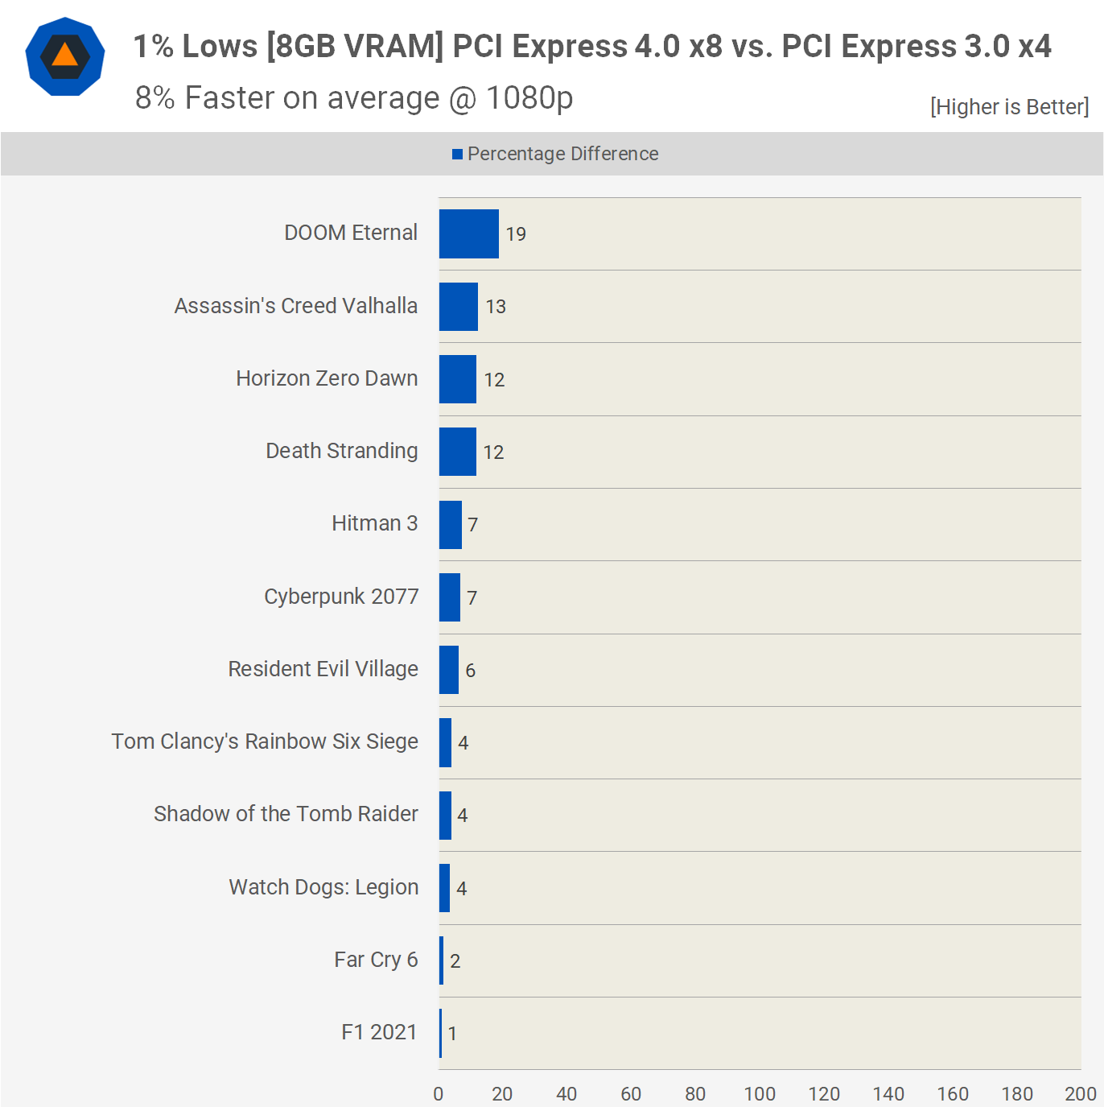

Here's a short glance at the 1% low data for those of you who are interested. When comparing 1% lows, the gap for the 4GB model jumps to 56 percent, with most titles having a margin of at least 30 percent.

The performance of the 8GB variant, on the other hand, is much more constant. When compared to PCIe 3.0 x4, the PCIe 4.0 x8 design offers an 8 percent gain on average.

**What We Learned**

That was a fascinating experiment with some very striking outcomes. In games like Watch Dogs: Legion and Far Cry 6, the 4GB version of the 5500 XT ran extremely close to the 8GB counterpart when given the full PCIe 4.0 x8 bandwidth that those GPUs allow.

Limiting the 4GB model to even PCIe 4.0 x4 significantly impacted performance, implying that the 6500 XT may be constrained largely by the PCIe connection out of the box, which is somewhat surprising. It also recommends that putting the 6500 XT on a system that only supports PCI Express 3.0 might be detrimental to performance in many cases.



At this time, we believe that all reviewers should be aware of this and test the 6500 XT in PCIe 3.0 mode. You can easily flip between 3.0 and 4.0 in the BIOS, so there's no need not to. Of course, AMD is hoping that reviewers will ignore this, and with the majority of them now testing on PCIe 4.0 systems, the 6500 XT may wind up seeming a lot better than it is for customers.

It's worth remembering that PCI Express 3.0 is the only option for the great majority of gamers. For example, Intel only began supporting PCIe 4.0 with 11th-generation CPUs when utilising a 500 series motherboard, but AMD began supporting PCIe 4.0 with certain Ryzen 3000 processors that needed an X570 or B550 motherboard.

If you have an AMD B450 motherboard, for example, you're limited to PCIe 3.0. Furthermore, regardless of the motherboard used, AMD's latest budget CPUs, such as the Ryzen 5 5600G, are limited to PCIe 3.0. With the exception of the new Alder Lake components, anybody who has purchased a budget CPU to date will be confined to PCI Express 3.0.

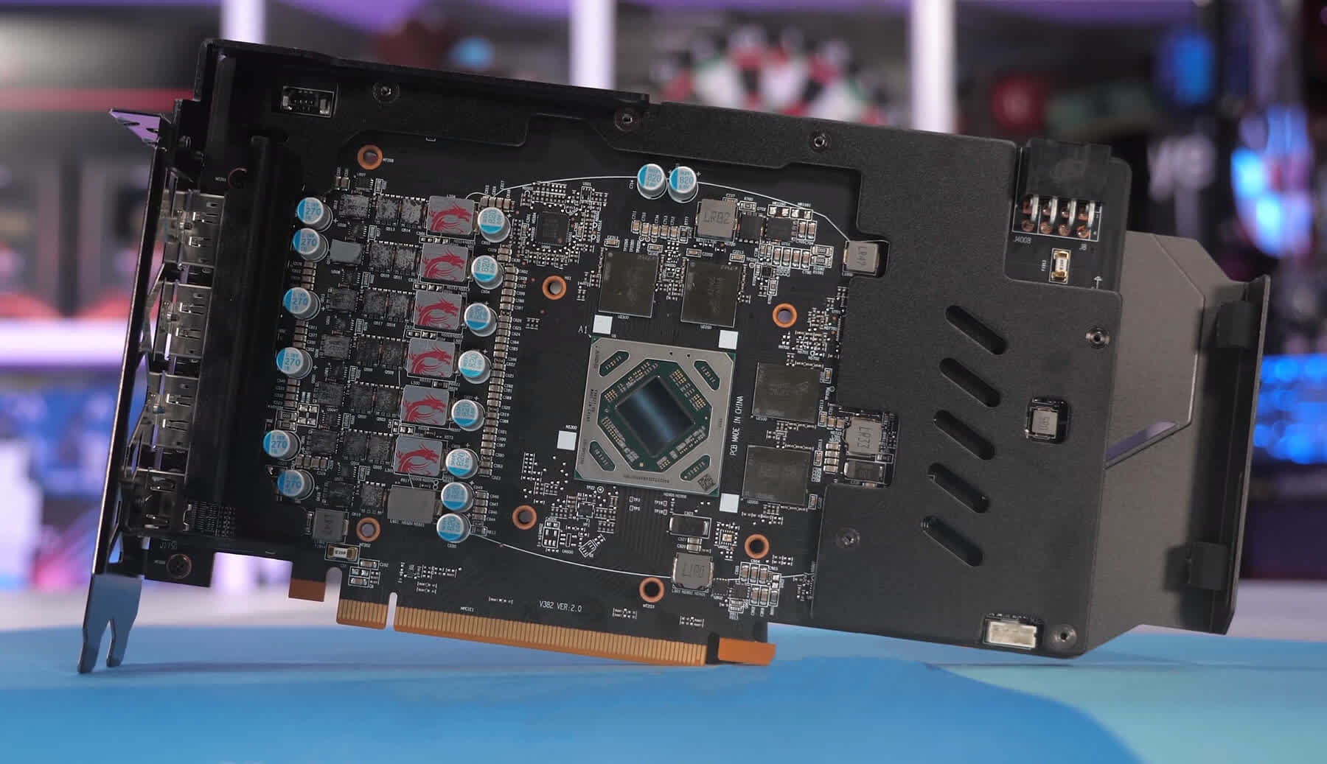

You could argue that F1 2021 and Resident Evil Village, where VRAM usage was well below 4GB, meant that the 4GB 5500XT worked just fine even with PCIe 3.0x4 bandwidth. While performance should not be affected by these conditions, it is true that it is difficult to ensure VRAM usage stays below 4GB in current titles. In many cases, it is impossible.

Even if you know this stuff and are able to monitor it, unless your goal is for 3GB or less it can be difficult to gauge how close you are to the edge. The problem is that the 4GB 5500XT was often too close to the edge. It was able to get away with the full PCIe 4.x8 bandwidth without much performance loss. However, when it tried PCIe 3.0x4 bandwidth it nearly always had trouble and sometimes couldn't manage any performance.

This isn't about extreme cases where performance dropped to an unacceptable level. It's more about the card's noticeable slowdown when it uses PCIe 3.0x4 bandwidth. The 5500XT saw an average of 82 frames per second at 1080p. This is a 30% decrease in performance.

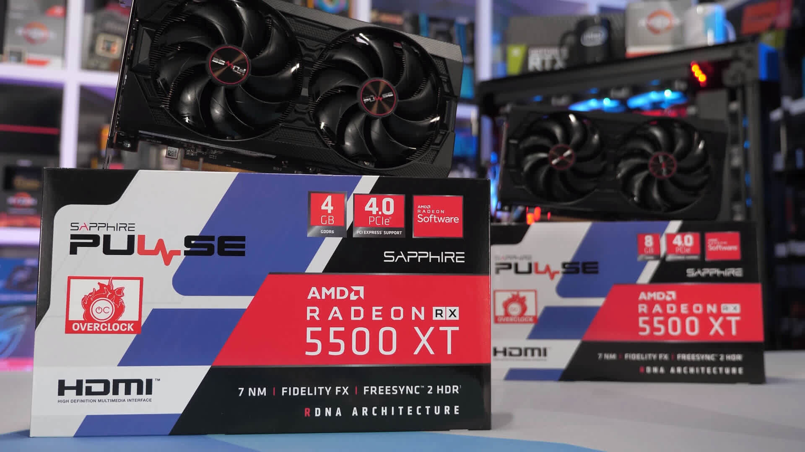

It's worth remembering that PCI Express 3.0 is the only option for the great majority of gamers. For example, Intel only began supporting PCIe 4.0 with 11th-generation CPUs when utilising a 500 series motherboard, but AMD began supporting PCIe 4.0 with certain Ryzen 3000 processors that needed an X570 or B550 motherboard.

If you have an AMD B450 motherboard, for example, you're limited to PCIe 3.0. Furthermore, regardless of the motherboard used, AMD's latest budget CPUs, such as the Ryzen 5 5600G, are limited to PCIe 3.0. With the exception of the new Alder Lake components, anybody who has purchased a budget CPU to date will be confined to PCI Express 3.0.